#### DESIGING ARC WELDING APLLICATION ALONG WITH CONVEYOR USING SEQUENCE PROGRAMMING

***PRAGATI ENGINEERING COLLEGE***

***IVTH YEAR MECHANICAL***

***BATCH MEMEBERS***

***ASHISH KUMAR 16A31A0364***

***B.BALAJI 16A31A0365***

***CH. PHAEENDRA RAJU 16A31A0368***

***S. NOOKARAJU 16A31A03A9***

**ABSTRACT**

*Robot welding is mainly concerned with the use of mechanized programmable tools, known as robots, which completely automate a welding process by both performing the weld and handling the part. Robots are quite versatile and hence have been used for a variety of welding types such as resistance welding and arc welding. This Project describes the development and progress of robotization in welding over the years. Traditionally, spot welding process has been the biggest use of robots especially in the automotive industry. It focuses on the arc welding processes which have been dominantly used in the various industries. The critical features of the robotic welding system for maximizing the welding quality, operational flexibility and productivity are discussed. These features are in the robot configurations, sensing, programming, work piece handling, as well as welding process control. A robot the size of a person can easily carry a load over one hundred pounds and move it very quickly with a repeatability of +/-0.006 inches. Furthermore, these robots can do that 24hours a day for years on end with no failures whatsoever. Though they are reprogrammable, in many applications (particularly those in the auto industry) they are programmed once and then repeat that exact same task for years.*

*These can also be prepared by (PLC) Programmable Logic controller (PLC) is a specialized computer used for the control and operation of Manufacturing process and machinery. It uses a programmable memory to store instructions and execute functions including on/off control, timing, counting, sequencing, arithmetic, and data handling. Where older automated systems would use hundreds or thousands of electromechanical relays, single PLC can be programmed as an efficient replacement. The functionality of the PLCs has evolved over the years to include capabilities beyond typical relay control, sophisticated motion control; process control, distributive control systems, and complex networking have now been added to the PLC’s Functions.*

*Supervisory control and data acquisition (SCADA) allows a utility operator to monitor and control process that is distributed among various remote sites. SCADA is a system for gathering real time data, controlling processes and monitoring equipment from remote location. As more companies are implementing an open SCADA architecture through the Internet to monitor critical infrastructure components such as power plant, oil and gas pipelines, chemical refineries, flood control dams and waste and water system, vital system are becoming increasingly open to attack.*

## *The Project is based on systematic conveyor controller programming by using MOTOSIM EG software which is used to control the action of Robot along with WPLSoft2.48 software which controls the action of PLC’s along with that the SCADA Program will Controls all the robot working and PLC’s action through the SCADA program using Wonderware Intouch Software.*

## TABLE OF CONTENTS

## 1

## ROBOTICS INTRODUCTION

## *HISTORY*

## *ROBOTIC ASPECTS*

## *LAWS OF ROBOTICS*

## *COMPONENTS OF INDUSTRIAL ROBOTS*

## *48*

## INTRODUCTION TO ROBOT WELDING TECHOLOGY

## *HISTORY OF WELDING*

## *WELDING ROBOTS*

## *ARC WELDING SETUP*

## 60

## INTRODUCTION TO ROBOT SIMULATION SOFTWARE

## *MOTOSIM EG SOFTWARE*

## *SETPS IN VOLVED IN ARC WELDING APPLICATION ALONG WITH CONVEYOR*

## 78

## INTRODUCTION TO PROGRAMMING LOGIC CONTROLLER

## *PLC*

## *EVOLUTION OF PLC*

## *STEPS INVOLVED IN PLC SOFTWARE (DELTA PLC/WPL SOFTWARE)*

## *92*

## INTRODUCTION TO SUPERVISORY AND DATA ACQUISTION (SCADA)

## *SOFTWARE INTRODUCTION (WONDERWARE SOFTWARE)*

## *FUTURE SCOPE*

## *CONCLUSION*

## 

**INTRODUCTION**

Robotics is an [interdisciplinary](https://en.wikipedia.org/wiki/Interdisciplinarity) branch of [engineering](https://en.wikipedia.org/wiki/List_of_engineering_branches) and [science](https://en.wikipedia.org/wiki/Branch_of_science) that includes [mechanical engineering](https://en.wikipedia.org/wiki/Mechanical_engineering), [electronic engineering](https://en.wikipedia.org/wiki/Electronic_engineering), [information engineering](https://en.wikipedia.org/wiki/Information_engineering_(field)), [computer science](https://en.wikipedia.org/wiki/Computer_science), and others. Robotics deals with the design, construction, operation, and use of [robots](https://en.wikipedia.org/wiki/Robot), as well as [computer systems](https://en.wikipedia.org/wiki/Computer_system) for their control, [sensory feedback](https://en.wikipedia.org/wiki/Sensory_feedback), and [information processing](https://en.wikipedia.org/wiki/Information_processing).

These technologies are used to develop machines that can substitute for humans and replicate human actions. Robots can be used in many situations and for lots of purposes, but today many are used in dangerous environments (including [bomb detection](https://en.wikipedia.org/wiki/Bomb_detection) and [deactivation](https://en.wikipedia.org/wiki/Bomb_disposal)), manufacturing processes, or where humans cannot survive (e.g. in space, under water, in high heat, and clean up and containment of hazardous materials and radiation). Robots can take on any form but some are made to resemble humans in appearance. This is said to help in the acceptance of a robot in certain replicative behaviors usually performed by people. Such robots attempt to replicate walking, lifting, speech, cognition, or any other human activity. Many of today's robots are inspired by nature, contributing to the field of [bio-inspired robotics](https://en.wikipedia.org/wiki/Bio-inspired_robotics).

The concept of creating machines that can operate [autonomously](https://en.wikipedia.org/wiki/Autonomous_robot) dates back to [classical times](https://en.wikipedia.org/wiki/Classical_times), but research into the functionality and potential uses of robots did not grow substantially until the 20th century. Throughout history, it has been frequently assumed by various scholars, inventors, engineers, and technicians that robots will one day be able to mimic human behavior and manage tasks in a human-like fashion. Today, robotics is a rapidly growing field, as technological advances continue; researching, designing, and building new robots serve various practical purposes, whether [domestically](https://en.wikipedia.org/wiki/Domestic_robot), [commercially](https://en.wikipedia.org/wiki/Industrial_robot), or [militarily](https://en.wikipedia.org/wiki/Military_robot). Many robots are built to do jobs that are hazardous to people, such as defusing bombs, finding survivors in unstable ruins, and exploring mines and shipwrecks. Robotics is also used in [STEM](https://en.wikipedia.org/wiki/Science,_technology,_engineering,_and_mathematics) (science, [technology](https://en.wikipedia.org/wiki/Technology), engineering, and mathematics) as a teaching aid. The advent of nanorobots, microscopic robots that can be injected into the human body, could revolutionize medicine and human health.

Robotics is a branch of engineering that involves the conception, design, manufacture, and operation of robots. This field overlaps with **electronics, computer science, artificial intelligence, mechatronics, nanotechnology and bioengineering**.

The word *robotics* was derived from the word *robot*, which was introduced to the public by [Czech](https://en.wikipedia.org/wiki/Czechoslovakia) writer [Karel Čapek](https://en.wikipedia.org/wiki/Karel_%C4%8Capek" \o "Karel Čapek) in his play [*R.U.R. (Rossum's Universal Robots)*](https://en.wikipedia.org/wiki/R.U.R._(Rossum%27s_Universal_Robots)), which was published in 1920. The word *robot* comes from the Slavic word *robata*, which means labour/work. The play begins in a factory that makes artificial people called *robots*, creatures who can be mistaken for humans – very similar to the modern ideas of [androids](https://en.wikipedia.org/wiki/Android_(robot)). Karel Čapek himself did not coin the word. He wrote a short letter in reference to an [etymology](https://en.wikipedia.org/wiki/Etymology) in the [*Oxford English Dictionary*](https://en.wikipedia.org/wiki/Oxford_English_Dictionary) in which he named his brother [Josef Čapek](https://en.wikipedia.org/wiki/Josef_Capek) as its actual originator.

According to the [*Oxford English Dictionary*](https://en.wikipedia.org/wiki/Oxford_English_Dictionary), the word *robotics* was first used in print by [Isaac Asimov](https://en.wikipedia.org/wiki/Isaac_Asimov), in his [science fiction](https://en.wikipedia.org/wiki/Science_fiction) short story [*"Liar!"*](https://en.wikipedia.org/wiki/Liar!_(short_story)), published in May 1941 in [*Astounding Science Fiction*](https://en.wikipedia.org/wiki/Analog_Science_Fiction_and_Fact). Asimov was unaware that he was coining the term; since the science and technology of electrical devices is *electronics*, he assumed *robotics* already referred to the science and technology of robots. In some of Asimov's other works, he states that the first use of the word *robotics* was in his short story [*Runaround*](https://en.wikipedia.org/wiki/Runaround_(story)) ([Astounding Science Fiction](https://en.wikipedia.org/wiki/Analog_Science_Fiction_and_Fact), March 1942), where he introduced his concept of [The Three Laws of Robotics](https://en.wikipedia.org/wiki/Three_Laws_of_Robotics). However, the original publication of "Liar!" predates that of "Runaround" by ten months, so the former is generally cited as the word's origin.

**History**

Fully autonomous only appeared in the second half of the 20th century. The first digitally operated and programmable robot, the Unimate, was installed in 1961 to lift hot pieces of metal from a die casting machine and stack them. Commercial and industrial robots are widespread today and used to perform jobs more cheaply, more accurately and more reliably, than humans. They are also employed in some jobs which are too dirty, dangerous, or dull to be suitable for humans. Robots are widely used in manufacturing, assembly, packing and packaging, mining, transport, earth and space exploration, surgery, weaponry, laboratory research, safety, and the mass production of consumer and industrial goods.

|  |  |  |  |
| --- | --- | --- | --- |
| **Date** | **Significance** | **Robot name** | **Inventor** |
| Third century B.C. and earlier | One of the earliest descriptions of automata appears in the [*Lie Zi*](https://en.wikipedia.org/wiki/Lie_Zi) text, on a much earlier encounter between [King Mu of Zhou](https://en.wikipedia.org/wiki/King_Mu_of_Zhou) (1023–957 BC) and a mechanical engineer known as Yan Shi, an 'artificer'. The latter allegedly presented the king with a life-size, human-shaped figure of his mechanical handiwork. |  | Yan Shi |
| First century A.D. and earlier | Descriptions of more than 100 machines and automata, including a fire engine, a wind organ, a coin-operated machine, and a steam-powered engine, in *Pneumatica* and *Automata* by [Heron of Alexandria](https://en.wikipedia.org/wiki/Hero_of_Alexandria) |  | [Ctesibius](https://en.wikipedia.org/wiki/Ctesibius), [Philo of Byzantium](https://en.wikipedia.org/wiki/Philo_of_Byzantium), Heron of Alexandria, and others |
| c. 420 B.C | A wooden, steam propelled bird, which was able to fly | Flying pigeon | Archytas of Tarentum |
| 1206 | Created early humanoid automata, programmable automaton band | Robot band, hand-washing automaton, automated moving peacocks | [Al-Jazari](https://en.wikipedia.org/wiki/Al-Jazari) |
| 1495 | Designs for a humanoid robot | [Mechanical Knight](https://en.wikipedia.org/wiki/Leonardo%27s_robot) | [Leonardo da Vinci](https://en.wikipedia.org/wiki/Leonardo_da_Vinci) |
| 1738 | Mechanical duck that was able to eat, flap its wings, and excrete | [Digesting Duck](https://en.wikipedia.org/wiki/Digesting_Duck) | [Jacques de Vaucanson](https://en.wikipedia.org/wiki/Jacques_de_Vaucanson) |
| 1898 | Nikola Tesla demonstrates first radio-controlled vessel. | Teleautomaton | [Nikola Tesla](https://en.wikipedia.org/wiki/Nikola_Tesla) |
| 1921 | First fictional automatons called "robots" appear in the play *R.U.R.* | [Rossum's Universal Robots](https://en.wikipedia.org/wiki/Rossum%27s_Universal_Robots) | [Karel Čapek](https://en.wikipedia.org/wiki/Karel_%C4%8Capek) |
| 1930s | Humanoid robot exhibited at the 1939 and 1940 [World's Fairs](https://en.wikipedia.org/wiki/World%27s_fair). | [Elektro](https://en.wikipedia.org/wiki/Elektro) | [Westinghouse Electric Corporation](https://en.wikipedia.org/wiki/Westinghouse_Electric_(1886)) |
| 1946 | First general-purpose digital computer | [Whirlwind](https://en.wikipedia.org/wiki/Whirlwind_I) | Multiple people |
| 1948 | Simple robots exhibiting biological behaviors. | Elsie and Elmer | [William Grey Walter](https://en.wikipedia.org/wiki/William_Grey_Walter) |
| 1956 | First commercial robot, from the Unimation company founded by [George Devol](https://en.wikipedia.org/wiki/George_Devol) and [Joseph Engelberger](https://en.wikipedia.org/wiki/Joseph_Engelberger), based on Devol's patents. | [Unimate](https://en.wikipedia.org/wiki/Unimate) | [George Devol](https://en.wikipedia.org/wiki/George_Devol) |
| 1961 | First installed industrial robot. | [Unimate](https://en.wikipedia.org/wiki/Unimate) | [George Devol](https://en.wikipedia.org/wiki/George_Devol) |
| 1967 to 1972 | First full-scale humanoid intelligent robot, and first [android](https://en.wikipedia.org/wiki/Android_(robot)). Its limb control system allowed it to walk with the lower limbs, and to grip and transport objects with hands, using tactile sensors. Its vision system allowed it to measure distances and directions to objects using external receptors, artificial eyes and ears. And its conversation system allowed it to communicate with a person in Japanese, with an artificial mouth. | WABOT-1 | [Waseda University](https://en.wikipedia.org/wiki/Waseda_University) |
| 1973 | First [industrial robot](https://en.wikipedia.org/wiki/Industrial_robot) with six electromechanically driven axes. | Famulus | [KUKA Robot Group](https://en.wikipedia.org/wiki/KUKA) |
| 1974 | The world's first [microcomputer](https://en.wikipedia.org/wiki/Microcomputer) controlled electric industrial robot, IRB 6 from ASEA, was delivered to a small mechanical engineering company in southern Sweden. The design of this robot had been patented already 1972. | IRB 6 | [ABB Robot Group](https://en.wikipedia.org/wiki/ABB) |
| 1975 | Programmable universal manipulation arm, a Unimation product | [PUMA](https://en.wikipedia.org/wiki/Programmable_Universal_Machine_for_Assembly) | [Victor Scheinman](https://en.wikipedia.org/wiki/Victor_Scheinman) |
| 1978 | First object-level robot programming language, allowing robots to handle variations in object position, shape, and sensor noise. | [Freddy I and II, RAPT robot programming language](https://en.wikipedia.org/wiki/Freddy_II) | [Patricia Ambler](https://en.wikipedia.org/wiki/Pat_Ambler) and [Robin Popplestone](https://en.wikipedia.org/wiki/Robin_Popplestone) |
| 1983 | First multitasking, parallel programming language used for a robot control. It was the Event Driven Language (EDL) on the IBM/Series/1 process computer, with implementation of both inter process communication (WAIT/POST) and mutual exclusion (ENQ/DEQ) mechanisms for robot control. | ADRIEL I | Stevo Bozinovski and Mihail Sestakov |

## The invention of the industrial robot dates back to 1954 when George Devol filed a patent on a programmed article transfer .After teaming up with Joseph Engelberger, the first robot company, Unimation , was founded and put the first robot into service at a General Motors plant in 1961 for extracting parts from a die-casting machine. Most of the hydraulically actuated Unimates were sold through the following years for workpiece handling and for spot-welding of car bodies [42.5]. Both applications were successful, which means that the robots worked reliably and ensured uniform quality. Soon, many other companies

## robotpatent.jpg

## The all electric IRB-6 First introduced in 1973, the IRB-6 has been a breakthrough development as it was the first serially-produced robot product, which combined all-electric-drives technology and a microcomputer for programming and motion control. The robot proved very robust. Life-times of more than 20 years in harsh productions were reported (by courtesy ABB Automation, Friedberg)

## preview.jpg

## Also in 1973 KUKA Robotics built its first robot, known as FAMULUS, also one of the first articulated robots to have six electromechanically driven axes.

## download.png

## Cincinnati Milacron T3 In 1974, Cincinnati Milacron introduced the first microcomputer controlled robot. The first T3 (The Tomorrow Tool) models used hydraulic drives, later they were replaced by electric motors. The CM robotics division was acquired by ABB in the late 1970s

## Spot-welding line and videocassette recorder (VCR) assembly as pioneering applications for industrial robot applications. Spot welding quickly became a primary application for robots as these jobs were particularly exhausting and hazardous for workers. A typical car body welding line from 1985 is displayed. The car model shown is a French Citroën CX

## Screenshot (27).png

## Robb the ABB Flex Picker parallel robot for high speed picking and the KUKA light weight robot arm Parallel kinematic machines (PKM) represent an interesting approach to achieve high stiffness at low inertia, thus allowing accurate, high speed motions. Initially suggested by Clavel this 4 axis robot (called Delta) is used for high speed pick-and-place tasks. The robot reaches accelerations of up to 10 g

## Screenshot (29).png

## Requirements regarding a robot’s speed and weight have led to novel kinematic and transmission designs. From early on, the reduction of the mass and inertia of robot structures was a primary research target, where the human arm with a weight-to-load ratio of 1:1 was considered the ultimate benchmark. In 2006, this goal was reached in the form of the company KUKA lightweight robot, a compact 7-DOF robot arm with advanced force control capabilities.

## Later on many robots are manufactured based on the requirements and some of the revolutionary robots prepared are MOTOMAN’ S DA-20 (2005) dual armed robot with two six axis arms, MORO (mobile robot, 1984), developed at Frauenhofer IPA, Stuttgart, was one of the first prototypes to combine a robot arm on a wire-bound mobile platform which follows a wire buried in the floor. Mobile arms were particularly used in highly automated clean room manufacturing facilities to automatically load and unload process equipment, an automated forklift my MLR a fully autonomous robot with automatically palletization.

## In parallel to industrial robots automated guided vehicles (AGVs) have emerged. These mobile robots are used for moving work pieces or loading equipment from point to point. Within the concept of automated flexible manufacturing systems (FMS) AGVs have become an important part of their routing flexibility. Initially AGVs relied on prepared floors such as embedded wires or magnets for motion guidance.

## By 2007, the evolution of industrial robots was marked by the following main trends:

## • The average robot unit price fell to about one-third of its equivalent price in 1990, which meant that automation is becoming more affordable. At the same time, robot performance parameters such as speed, load capacity, and mean time between failures (MTBF) have dramatically improved. These improvements provide a faster return on investment, particularly for small, short-run batch production.

## • Off-the-shelf components from personal computer (PC) technologies, consumer software, and the IT industry have contributed to improved performance to cost ratios. Today, most manufacturers integrate PC-based processors in their controllers as well as software for programming, communication, simulation, and maintenance from high-volume IT markets.

## • Multiple robots can be programmed and synchronized in real time by one controller, which allows robots to cooperate precisely on a single work piece.

## • Increasingly, vision systems for object identification, localization, and quality control have become an integral part of the robot controller.

## • Robots are networked by field buses or Ethernet for control, configuration, and maintenance.

## • New financing arrangements allow end-users to rent a robot or even have a robot work cell operated by a specialized company or even the robot supplier in order to reduce risks or to save on investment capital.

## • Training and education have become important services to end-users to increase acceptance of robot technology. Specific multimedia material and courses aim at educating industrial engineers and workforce to effectively plan, program, operate, and maintain industrial robot work cells.

## ROBOTIC ASPECTS

There are many types of robots; they are used in many different environments and for many different uses. Although being very diverse in application and form, they all share three basic similarities when it comes to their construction:

1. Robots all have some kind of mechanical construction, a frame, form or shape designed to achieve a particular task. The mechanical aspect is mostly the creator's solution to completing the assigned task and dealing with the physics of the environment around it.

Form follows function.

1. Robots have electrical components which power and control the machinery. For example, the robot with caterpillar tracks would need some kind of power to move the tracker treads. That power comes in the form of electricity, which will have to travel through a wire and originate from a battery, a basic electrical circuit. Even petrol powered machines that get their power mainly from petrol still require an electric current to start the combustion process which is why most petrol powered machines like cars, have batteries. The electrical aspect of robots is used for movement (through motors), sensing (where electrical signals are used to measure things like heat, sound, position, and energy status) and operation (robots need some level of electrical energy supplied to their motors and sensors in order to activate and perform basic operations)
2. All robots contain some level of computer programming code. A program is how a robot decides when or how to do something. In the caterpillar track example, a robot that needs to move across a muddy road may have the correct mechanical construction and receive the correct amount of power from its battery, but would not go anywhere without a program telling it to move. Programs are the core essence of a robot, it could have excellent mechanical and electrical construction, but if its program is poorly constructed its performance will be very poor (or it may not perform at all). There are three different types of robotic programs: remote control, artificial intelligence and hybrid.
3. A robot with remote control programming has a preexisting set of commands that it will only perform if and when it receives a signal from a control source, typically a human being with a remote control. It is perhaps more appropriate to view devices controlled primarily by human commands as falling in the discipline of automation rather than robotics. Robots that use artificial intelligence interact with their environment on their own without a control source, and can determine reactions to objects and problems they encounter using their preexisting

**LAWS OF ROBOTICS**

Asimov proposed three “Laws of Robotics” and later added the “zeroth law”

• **Law 0:** A robot may not injure humanity or through inaction, allow humanity to come to harm.

**• Law 1:** A robot may not injure a human being or through inaction, allow a human being to come to harm, unless this would violate a higher order law.

• **Law 2:** A robot must obey orders given to it by human beings, except where such orders would conflict with a higher order law.

• **Law 3:** A robot must protect its own existence as long as such protection does not conflict with a higher order law.

***COMPONENTS AND STRUCTURE OF ROBOTS***

**SYMBOLIC REPRESENTATION OF ROBOTS**

Robot Manipulators are composed of links connected by joints into a kinematic chain. Joints are typically rotary (revolute) or linear (prismatic). A revolute joint is like a hinge and allows relative rotation between two links. A prismatic joint allows a linear relative motion between two links. We use the convention (R) for representing revolute joints and (P) for prismatic joints.

**COMPONENTS AND STRUCTURE OF ROBOTS**

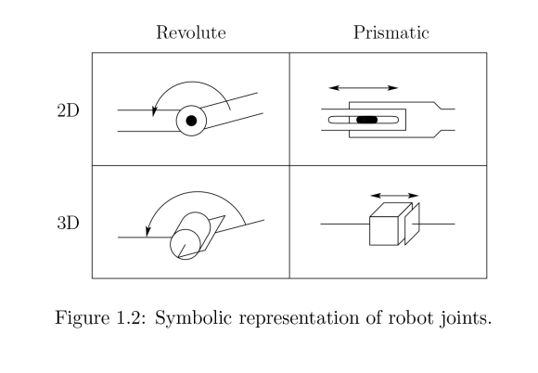

Each joint represents the interconnection between two links, say `i and `i+1. We denote the axis of rotation of a revolute joint, or the axis along which a prismatic joint slides by zi if the joint is

The interconnection of links i and i+1. The joint variables, denoted by -i for a revolute joint and di for the prismatic joint, represent the relative displacement between adjacent links.

**Robot Physical Configuration**

Industrial robots are available in a wide variety of sizes, shapes, and physical configurations. The vast majority of today’s commercially available robots possess one of the basic configurations:

1. Polar configuration

2. Cylindrical configuration

3. Cartesian coordinate configurable

4. Jointed-arm configuration

**Polar configuration:**

The polar configuration is pictured in part (a) of Fig. It uses a telescoping arm that can be raised or lowered about a horizontal pivot The pivot is mounted on a mta6ng base These various joints provide the robot with the capability to move its arm within a spherical space, and hence the name “spherical coordinate” robot is sometimes applied to this type. A number of commercial robots possess the polar configuration.



**Cylindrical Configuration:**

****

The cylindrical configurable, as shown in fig, uses a vertical column and a slide that can be moved up or down along the column. The robot arm is attached to the slide so that it cm he moved radially with respect to the column. By routing the column, the robot is capable of achieving a work space that approximation a cylinder.

**Cartesian coordinate Configurable:**

****

The Cartesian coordinate robot, illustrated in part Cc) of Fig, uses three perpendicular slides to construct the x, y, and z axes. Other names are sometimes applied W this configuration, including xyz robot and rectilinear robot, By moving the three slides relative to one another, the robot is capable of operating within a rectangular work envelope.

**Jointed-Arm Configuration:**

****

The jointed-arm robot is pictured in Fig. Its configuration is similar to that of the human arm. It consists of two straight components. Corresponding to the human forearm and upper arm, mounted on a vertical pedestal. These components are connected by two rotary joints corresponding to the shoulder and elbow.

**Mechanical structure of Industrial Robots**

Combination of links and joints. Relating it to a human body, parts that can freely bend and move about, such as the elbow and shoulder, are the joints, and the bones connecting those joints are equivalent to a robot’s links. The principle of moving joints and transmitting power through the links is common in both humans and robots.

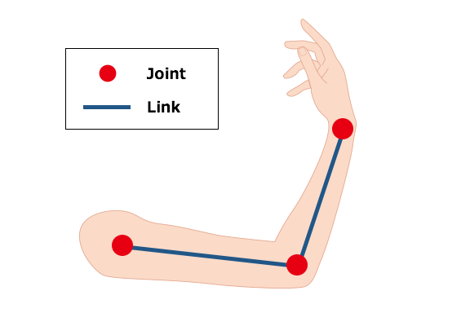

A human elbow and shoulder are joints and the bones connecting them are links.

Robots are roughly categorized into two types according to how their links are arranged:

1) Serial link and

2) Parallel link

The human arm is categorized as a serial link since its joints the shoulder, arm and wrist are aligned in series.

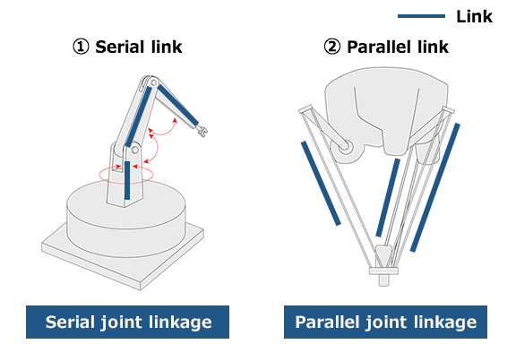

Industrial robots are classified into several categories such as vertical articulated type and horizontal articulated type (Selective Compliance Assembly Robot Arm-SCARA), depending on the joint movements and the structure. Please see the article below for more information.

**Robot and human motion comparison**

Now, let’s take a look at the movement of a vertical articulated type having the same mechanical structure as a human arm as an example. A vertical articulated robot is an industrial robot with a serial link structure. It is generally composed of six joints (6 axes).

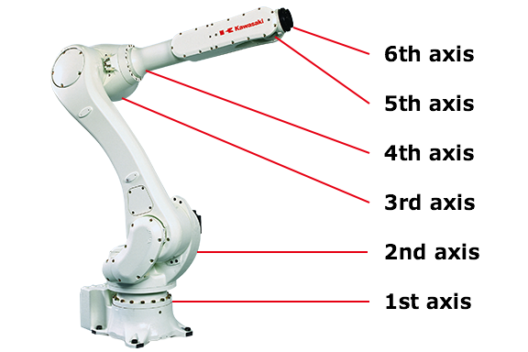

The following figure shows a comparison between robot and human movement.

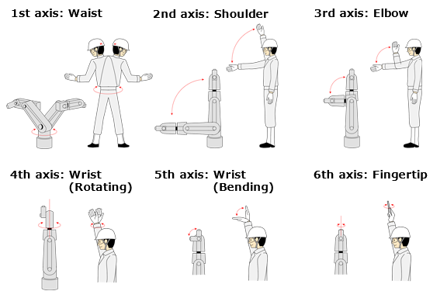

The 1st to the 3rd axes are the waist and the arm, and the 4th to the 6th axes are from the wrist up to the fingertips. The first three axes carry the wrist to a specific position, and the next three axes move the wrist freely. This 6-axis construction allows robots to move freely like humans can.

.

**COMPONENTS OF INDUSTRIAL ROBOTS**

A standard industrial robot has the following components, they are

1. Manipulator
2. End effectors
3. Drives
4. Controllers
5. Sensors

#### 1. Manipulator:

Just like the human arm, the robot consists of what is called a manipulator having several joints and links Manipulatorrefers to the anatomy of the robot which involves the structural components like wrist, base, arm which are connected by a series of joints and links. The mechanical structure of manipulator that consists of rigid bodies connected by means of joints, is segmented into an arm that ensures mobility and reach ability of the robot to required location. A manipulator is a device used to manipulate materials without direct physical contact by the [operator](https://en.wikipedia.org/wiki/Operator_(profession)). The applications were originally for dealing with radioactive or biohazard us materials, using [robotic arms](https://en.wikipedia.org/wiki/Robotic_arm), or they were used in inaccessible places. In more recent developments they have been used in diverse range of applications including welding automation, [robotic surgery](https://en.wikipedia.org/wiki/Robotic_surgery) and in [space](https://en.wikipedia.org/wiki/Robotic_arm). It is an arm-like mechanism that consists of a series of segments, usually sliding or jointed called cross-slides, which grasp and move objects with a number of freedom. In industrial ergonomics a manipulator is a lift-assist device used to help workers lift, maneuver and place articles in process that are too heavy, too hot, too large or otherwise too difficult for a single worker to manually handle. As opposed to simply vertical lift assists (cranes, hoists, etc.) manipulators have the ability to reach in to tight spaces and remove work pieces. A good example would be removing large stamped parts from a press and placing them in a rack or similar dunnage. In welding, a column boom manipulator is used to increase deposition rates, reduce human error and other costs in a manufacturing setting. Additionally, manipulator tooling gives the lift assist the ability to pitch, roll, or spin the part for appropriate placement. An example would be removing a part from a press in the horizontal and then pitching it up for vertical placement in a rack or rolling a part over for exposing the back of the part.

#### 2. End effectors:

The base of the manipulator is fixed to base support and at its other free end, the Endeffector is attached. The End effectors are expected to perform tasks normally performed by the palm and finger arrangements of the human arm. In the strict definition, which originates from serial robotic [manipulators](https://en.wikipedia.org/wiki/Manipulator_(device)), the end effectors means the last link (or end) of the robot. At this endpoint, the [tools](https://en.wikipedia.org/wiki/Tool) are attached. In a wider sense, end effectors can be seen as the part of a robot that interacts with the work environment. This does not refer to the wheels of a [mobile robot](https://en.wikipedia.org/wiki/Mobile_robot) or the feet of a [humanoid robot](https://en.wikipedia.org/wiki/Humanoid_robot), which are not end effectors but rather part of a robot's mobility. End effectors may consist of a gripper or a tool. When referring to robotic prehension there are four.

**GRIPPERS:**

**Impactive**: jaws or claws which physically grasp by direct impact upon the object.

**Ingressive**: pins, needles or hackles which physically penetrate the surface of the object (used in textile, carbon and glass fiber handling).

**Astrictive**: attractive forces applied to the objects surface (whether by vacuum, magneto- or electro adhesion).

**Contigutive**: requiring direct contact for adhesion to take place (such as glue, surface tension or freezing)

These categories describe the physical effects used to achieve a stable grasp between a gripper and the object to be grasped. Industrial grippers may employ mechanical, suction or magnetic means. Vacuum cups and electromagnets dominate the automotive field and metal sheet handling. [Bernoulli grippers](https://en.wikipedia.org/wiki/Bernoulli_grip) exploit the airflow between the gripper and the part, in which a lifting force brings the gripper and part close each other (using [Bernoulli's principle](https://en.wikipedia.org/wiki/Bernoulli%27s_principle)). Bernoulli grippers are a type of contactless grippers; the object remains confined in the force field generated by the gripper without coming into direct contact with it. Bernoulli grippers have been adopted in photovoltaic cell handling, [silicon wafer](https://en.wikipedia.org/wiki/Silicon_wafer) handling, and in the textile and leather industries. Other principles are less used at the macro scale (part size >5mm), but in the last ten years, have demonstrated interesting applications in micro-handling. Other adopted principles include: Electrostatic grippers and van der Waals grippers based on electrostatic charges (i.e. [van der Waals' force](https://en.wikipedia.org/wiki/Van_der_Waals%27_force)), capillary grippers and cryogenic grippers, based on a liquid medium, and ultrasonic grippers and laser grippers, two contactless-grasping principles. Electrostatic grippers use a charge-difference between gripper and part ([electrostatic force](https://en.wikipedia.org/wiki/Electrostatic_force)) often activated by the gripper itself, while van der Waals grippers are based those of the object. Capillary grippers use the surface tension of a liquid meniscus between the gripper and the part to center, align and grasp a part. Cryogenic grippers freeze a small amount of liquid, with the resulting ice supplying the necessary force to lift and handle the object (this principle is used also in food handling and in textile grasping). Even more complex are [ultrasonic](https://en.wikipedia.org/wiki/Ultrasound) grippers, where pressure [standing waves](https://en.wikipedia.org/wiki/Standing_wave) are used to lift up a part and trap it at a certain level (example of levitation are both at the micro level, in screw- and gasket-handling, and at the macro scale, in solar cell or silicon-wafer handling), and laser source that produces a pressure sufficient to trap and move micro parts in a liquid medium (mainly cells). Laser grippers are known also as tweezers. A particular category of friction/jaw grippers is that of needle grippers. These are called intrusive grippers, exploiting both friction and form-closure as standard mechanical grippers. The most known mechanical gripper can be of two, three or even five fingers.

The end effectors that can be used as tools serve various purposes, including spot-welding in an assembly, spray-painting where uniformity of painting is necessary, and other purposes where the working conditions are dangerous for human beings. Surgical robots have end effectors that are

## Gripper mechanism

A common form of robotic grasping is [force closure](https://en.wikipedia.org/wiki/Robotic_force_closure).

Generally, the gripping mechanism is done by the grippers or mechanical fingers. Two-finger grippers tend to be used for industrial robots performing specific tasks in less-complex applications. The fingers are replaceable. Two types of mechanisms used in two-finger gripping account for the shape of the surface to be gripped, and the force required to grip the object.

The shape of the fingers' gripping surface can be chosen according to the shape of the objects to be manipulated. For example, if a robot is designed to lift a round object, the gripper surface shape can be a concave impression of it to make the grip efficient. For a square shape, the surface can be a plane.

### Force required to grip an object

Though there are numerous forces acting over the body that has been lifted by a robotic arm, the main force is the frictional force. The gripping surface can be made of a soft material with high coefficient of friction so that the surface of the object is not damaged. The robotic gripper must withstand not only the weight of the object but also acceleration and the motion that is caused by frequent movement of the object. To find out the force required to grip the object, the following formula is used

{\displaystyle F={\frac {ma}{\mu n}}} **F = m a μ n {\displaystyle F={\frac {ma}{\mu n}}} *F = ma/un***

Where:

|  |  |  |
| --- | --- | --- |
| {\displaystyle \,F}F = | is | the force required to grip the object, |
| {\displaystyle \,m}m = | is | the mass of the object, |
| {\displaystyle \,a}a = | is | the acceleration of the object, |
| {\displaystyle \,\mu }u = | is | the coefficient of friction and |
| {\displaystyle \,n}n = | is | the number of fingers in the gripper. |

A more complete equation would account for the direction of movement. For example, when the body is moved upwards, against gravitational force, the force required will be more than that towards the gravitational force. Hence, another term is introduced and the formula becomes:

{\displaystyle F={\frac {m(a+g)}{\mu n}}} **F=m (a+g)/un**

Here, the value of**{\displaystyle \,g}g** should be taken as the acceleration due to gravity and **{\displaystyle \,a}a** the acceleration due to movement.

## Tools as end effectors

*A*tool*is equipped in the robot for carrying out*several operations*on the work parts instead of grasping it. A tool acts as*end effectors*when it is attached directly to the*robot’s wrist*. In some applications, there will be a need for multi-tool task, and changing the tool all the time from the robot wrist will be*highly difficult*. As a result, a*gripper*is used in this process to grasp and manipulate the tool. It certainly helps the robot to handle several tools in an operation, and thus makes the*multi-tooling function*possible. Moreover, the time taken to change the tool is*very low*.* For example*: In a deburring operation, various sizes of deburring tool will be required to hold for reaching every surface of the work part. Here, the tool is equipped in the gripper for quick exchange from one tool to another*.

### Examples for tools used as end effectors:

In robot applications, the most commonly used three tools as end effectors are listed below:

* Spot welding tools
* Spray painting nozzle
* Arc welding torch

The rotating spindle for routing, drilling, grinding, and wire brushing operations also comes under this category. Some other examples of tools used as end effectors are liquid cement applicators, water jet cutting tool, and heating torches.

#### 3. The Locomotion Device or Drives or Actuators:

In the case of Human Beings the power for the movement of the arm, the palm and fingers is provided by muscles. For the robot the power for the movement (locomotion) is provided by the motors. The motors used for providing locomotion in robots are of three types depending on the source of energy: Electric, Hydraulic or Pneumatic.

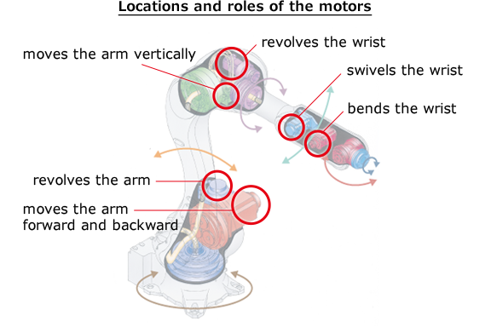

There are several different types of motors. Each motor type has several advantages as well as

Disadvantages depending on a particular robots design

1. **AC-motors**
2. **DC-motors**
   * Brushed DC motor
   * Brushless DC motor
   * Geared DC motor
3. [**Servo**](https://en.wikibooks.org/wiki/Robotics/Components/Actuation_Devices/Motors#Servo)
4. [**Stepper motor**](https://en.wikibooks.org/wiki/Robotics/Components/Actuation_Devices/Motors#Stepper_motor)

### DC Linear Actuator

### AC-motors:

There are several different types of AC-motors, but their use is limited to high power stationary

Industrial robots. They are harder to use than DC-motors. AC (alternating current) motors are rarely used in mobile robots because most of the robots are powered with direct current (DC) coming from batteries. Also, since electronic components use DC, it is more convenient to have the same type of power supply for the actuators as well. AC motors are mainly used in industrial environments where very high torque is required, or where the motors are connected to the mains / wall outlet.

### DC-motors:

DC-motors are very easy to use, but like most other motors their usefulness for robotics is very dependent on the gearing available. DC-motors are made much more effective if they have an efficient gear ratio for a particular task. If your priority is to have a fast spinning motor and torque is of little concern a low gearing or even no gearing may be what you need; however, most motors used in robots need torque over top speed so a motor with a high gear ratio could be more useful. The control of a DC motor can be split into two parts: speed and direction.

#### Direction

[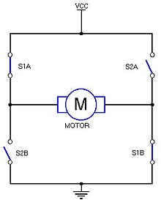](https://commons.wikimedia.org/wiki/File:H-bridge.jpg)

The principle behind a H-bridge

Changing direction in which a DC-motor turns is very easy: simply reverse the polarity.

Both pairs of switches ((S1A, S1B) and (S2A, S2B))-see the picture will always switch together. This circuit is called an H-bridge. In a real design the switches can be several different components (Relays, transistors, FETs) or the whole circuit (without the motor) could be an IC (integrated circuit). Use sugarcane relays

#### Speed

Speed is a little bit more complicated. Many beginners would try to slow down a motor by reducing its voltage with a variable resistor or other ways. This does not work well, because it will not only reduce the motor's speed, it will also reduce a motor's strength, while also consuming a lot of electricity as large amounts of heat are generated by the resistor.A far better way is to use a PWM (Pulse-width modulation) device.

**Servo Motor**

A servo motor is an electrical device which can push or rotate an object with great precision. If you want to rotate and object at some specific angles or distance, then you use servo motor. It is just made up of simple motor which run through servo mechanism. If motor is used is DC powered then it is called DC servo motor, and if it is AC powered motor then it is called AC servo motor. We can get a very high torque servo motor in a small and light weight packages. Doe to these features they are being used in many applications like robotics, Machine etc. The position of a servo motor is decided by electrical pulse and its circuitry is placed beside the motor.

Now day’s servo system has huge industrial applications. Servo motor applications are also commonly seen in remote controlled toy cars for controlling direction of motion and it is also very commonly used as the motor which moves the tray of a CD or DVD player. Beside these there are other hundreds of servo motor applications we see in our daily life. The main reason behind using a servo is that it provides angular precision, i.e. it will only rotate as much we want and then stop and wait for next signal to take further action. This is unlike a normal electrical motor which starts rotating as and when power is applied to it and the rotation continues until we switch off the power. We cannot control the rotational progress of electrical motor; but we can only control the speed of rotation and can turn it ON and OFF.

**Servo Mechanism:**

It consists of three parts:

* Controlled device
* Output sensor
* Feedback

It is a closed loop system where it uses positive feedback system to control motion and final position of the shaft. Here the device is controlled by a feedback signal generated by comparing output signal and reference input signal.

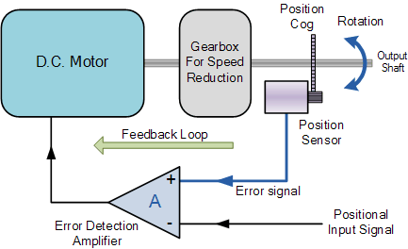

Here reference input signal is compared to reference output signal and the third signal is produces by feedback system. And this third signal acts as input signal to control device. This signal is present as long as feedback signal is generated or there is difference between reference input signal and reference output signal. So the main task of servomechanism is to maintain output of a system at desired value at presence of noises.

**Working principle of a servo motor**

A servo consists of a Motor (DC or AC), a potentiometer, gear assembly and a controlling circuit. First of all we use gear assembly to reduce RPM and to increase torque of motor. Say at initial position of servo motor shaft, the position of the potentiometer knob is such that there is no electrical signal generated at the output port of the potentiometer. Now an electrical signal is given to another input terminal of the error detector amplifier. Now difference between these two signals, one comes from potentiometer and another comes from other source, will be processed in feedback mechanism and output will be provided in term of error signal. This error signal acts as the input for motor and motor starts rotating. Now motor shaft is connected with potentiometer and as motor rotates so the potentiometer and it will generate a signal. So as the potentiometer’s angular position changes, its output feedback signal changes. After sometime the position of potentiometer reaches at a position that the output of potentiometer is same as external signal provided. At this condition, there will be no output signal from the amplifier to the motor input as there is no difference between external applied signal and the signal generated at potentiometer, and in this situation motor stops rotating.

**Controlling Servo Motor:**

**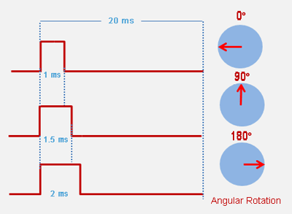**

Servo motor is controlled by PWM (Pulse with Modulation) which is provided by the control wires. There is a minimum pulse, a maximum pulse and a repetition rate. Servo motor can turn 90 degree from either direction form its neutral position. The servo motor expects to see a pulse every 20 milliseconds (ms) and the length of the pulse will determine how far the motor turns. For example, a 1.5ms pulse will make the motor turn to the 90° position, such as if pulse is shorter than 1.5ms shaft moves to 0° and if it is longer than 1.5ms than it will turn the servo to 180°. Servo motor works on PWM (Pulse width modulation) principle means its angle of rotation is controlled by the duration of applied pulse to its Control PIN. Basically servo motor is made up of DC motor which is controlled by a variable resistor (potentiometer) and some gears. High speed force of DC motor is converted into torque by Gears. We know that WORK= FORCE X DISTANCE, in DC motor Force is less and distance (speed) is high and in Servo, force is High and distance is less. Potentiometer is connected to the output shaft of the Servo, to calculate the angle and stop the DC motor on required angle.

To recap, there are two important differences between the control pulse of the servo motor versus the DC motor. First, on the servo motor, duty cycle (on-time vs. off-time) has no meaning whatsoever—all that matters is the absolute duration of the positive-going pulse, which corresponds to a commanded output position of the servo shaft. Second, the servo has its own power electronics, so very little power flows over the control signal. All power is draw from its power lead, which must be simply hooked up to a high-current source of 5 volts.

**Continuous Rotation Servo Motors**

Continuous rotation servo motors are actually a modified version of what the servos are actually meant to do, that is, control the shaft position. The 360° rotation servos are actually made by changing certain mechanical connections inside the servo. However, certain manufacturer like parallax sells these servos as well. With the continuous rotation servo you can only control the direction and speed of the servo, but not the position.

**Servo drive**

A servo drive is a special [electronic amplifier](https://en.wikipedia.org/wiki/Electronic_amplifier) used to power electric [servomechanisms](https://en.wikipedia.org/wiki/Servomechanism).

A servo drive monitors the [feedback](https://en.wikipedia.org/wiki/Feedback) signal from the servomechanism and continually adjusts for deviation from expected behavior.

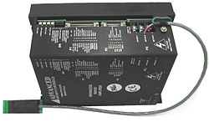

**Function**

A servo drive receives a command signal from a control system, amplifies the signal, and transmits electric current to a [servo motor](https://en.wikipedia.org/wiki/Servo_motor) in order to produce motion proportional to the command signal. Typically, the command signal represents a desired velocity, but can also represent a desired torque or position. A [sensor](https://en.wikipedia.org/wiki/Sensor) attached to the servo motor reports the motor's actual status back to the servo drive. The servo drive then compares the actual motor status with the commanded motor status. It then alters the voltage, [frequency](https://en.wikipedia.org/wiki/Frequency) or [pulse width](https://en.wikipedia.org/wiki/Pulse_width) to the motor so as to correct for any deviation from the commanded status.

In a properly configured control system, the servo motor rotates at a velocity that very closely approximates the velocity signal being received by the servo drive from the control system. Several parameters, such as stiffness (also known as proportional gain), damping (also known as derivative gain), and feedback gain, can be adjusted to achieve this desired performance. The process of adjusting these parameters is called [performance tuning](https://en.wikipedia.org/wiki/Performance_tuning).

Although many servo motors require a drive specific to that particular motor brand or model, many drives are now available that are compatible with a wide variety of motors.

**Digital and Analog**

Most servo drives used in industry are digital or analog. Digital drives differ from analog drives by having a microprocessor, or computer, which analyses incoming signals while controlling the mechanism. The microprocessor receives a pulse stream from an encoder which can determine parameters such as velocity. Varying the pulse, or blip, allows the mechanism to adjust speed essentially creating a speed controller effect. The repetitive tasks performed by a processor allow a digital drive to be quickly self-adjusting. In cases where mechanisms must adapt to many conditions, this can be convenient because a digital drive can adjust quickly with little effort. A drawback to digital drives is the large amount of energy that is consumed. However, many digital drives install capacity batteries to monitor battery life. The overall feedback system for a digital servo drive is like an analog, except that a microprocessor uses algorithms to predict system conditions.

Analog drives control velocity through various electrical inputs usually ±10 volts. Often adjusted with potentiometers, analog drives have plug in “personality cards” which are preadjusted to specific conditions. Most analog drives work by using a tach generator to measure incoming signals and produce a resulting torque demand. These torque demands request current in the mechanism depending on the feedback loop. This amplifier is referred as a four-quadrant drive because can accelerate, decelerate and brake in either rotating direction. Traditional analog drives consume less energy than digital drives and can offer very high performance in certain cases. When conditions are met, analog drives offer consistency with minimal “jitter” at standstills. Some analog servo drives do not need a torque amplifier and rely on velocity amplifiers for situation where speed is more important.

**Use in industry**

Servo systems can be used in CNC machining, factory automation, and robotics, among other uses. Their main advantage over traditional DC or AC motors is the addition of motor feedback. This feedback can be used to detect unwanted motion, or to ensure the accuracy of the commanded motion. The feedback is generally provided by an encoder of some sort. Servos, in constant speed changing use, have a better life cycle than typical AC wound motors. Servo motors can also act as a brake by shutting off generated electricity from the motor itself.

**Stepper Motor**

In robotics stepper motors are primarily used in stationary robots as they tend to consume quite a lot of power. They are ideal for movements that have to be accurate and are larger than 180°.A stepper motor is an electromechanical device which converts electrical pulses into discrete mechanical movements. The shaft or spindle of a stepper motor rotates in discrete step increments when electrical command pulses are applied to it in the proper sequence. The motors rotation has several direct relationships to these applied input pulses. The sequence of the applied pulses is directly related to the direction of motor shafts rotation. The speed of the motor shafts rotation is directly related to the frequency of the input pulses and the length of rotation is directly related to the number of input pulses applied.

Stepper motors are great motors for position control. They can be found in desktop printers, plotters, 3d printers, CNC milling machines, and anything else requiring precise position control. Steppers are a special segment of brushless motors. They are purposely built for high-holding torque. This high-holding torque gives the user the ability to incrementally “step” to the next position. This results in a simple positioning system that doesn’t require an encoder. This makes stepper motor controllers very simple to build and use.

One of the most significant advantages of a stepper motor is its ability to be accurately controlled in an open loop system. Open loop control means no feedback information about position is needed. This type of control eliminates the need for expensive sensing and feedback devices such as optical encoders. Your position is known simply by keeping track of the input step pulses.

**What are stepper motors good for?**

A stepper motor can be a good choice whenever controlled movement is required. They can be used to advantage in applications where you need to control rotation angle, speed, position and synchronism.

**Positioning** – Since steppers move in precise repeatable steps, they excel in applications requiring precise positioning such as 3D printers, CNC, Camera platforms and X,Y Plotters. Some disk drives also use stepper motors to position the read/write head.

**Speed Control** – Precise increments of movement also allow for excellent control of rotational speed for process automation and robotics.

**Low Speed Torque** - Normal DC motors don't have very much torque at low speeds. A Stepper motor has maximum torque at low speeds, so they are a good choice for applications requiring low speed with high precision.

**Types:**

There are three main types of stepper motors:

1. Permanent magnet stepper
2. Variable reluctance stepper
3. Hybrid synchronous stepper

Permanent magnet motors use a permanent magnet (PM) in the rotor and operate on the attraction or repulsion between the rotor PM and the stator electromagnets.Pulses move the rotor in discrete steps, CW or CCW. If left powered at a final step a strong detent remains at that shaft location. This detent has a predictable spring rate and specified torque limit; slippage occurs if the limit is exceeded. If current is removed a lesser detent still remains, therefore holding shaft position against spring or other torque influences. Stepping can then be resumed while reliably being synchronized with control electronics.

Variable reluctance (VR) motors have a plain iron rotor and operate based on the principle that minimum reluctance occurs with minimum gap, hence the rotor points are attracted toward the stator magnet poles. Whereas hybrid synchronous are a combination of the permanent magnet and variable reluctance types, to maximize power in a small size.VR motors do not have power off detents.

**NOTE : Among these electric motors servo motors are commonly and widely used because an induction motor cannot provide desired degree of rotation and a stepper motor cannot provide a feedback system which disturbs the repeatability where as a servo motor can provide both the desired degree of rotation and feedback system.**

**Reduction gear:**

A reduction gear is a device for increasing the power of a motor. A motor alone is limited in the amount of power it can output. In order to generate great power, motors are basically used in combination with this reduction gear. The areas circled in blue in the following illustration are the reduction gears.

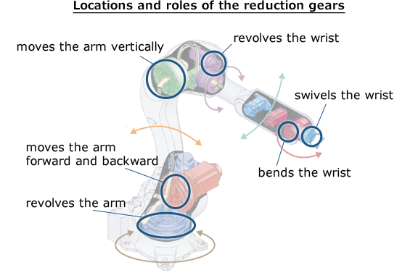

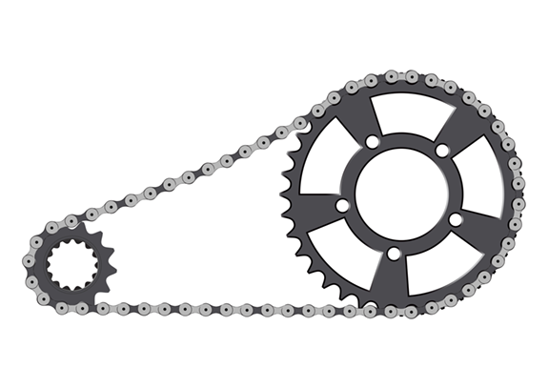

If you combine gear wheels with the different number of gears and reduce the motor’s rotation by a factor of 10, the power of the motor will be multiplied by 10. This is the same principle as a bicycle transmission. Bicycles have different sized gears in front and rear wheel. Generally, the transmission is used to change the gears of the rear wheel. When a large gear is selected and the number of wheel rotations is minimized, pedaling becomes easier at the cost of speed, but even riding up steep hills is much less difficult. In other words, the output power can be increased.

**Transmission:**

The transmission is a component that transmits the power generated by the actuators and reduction gears. The transmission is also capable of changing the direction and magnitude of power. Considering a bicycle as an example as before, the chain that connects the crank to the back wheel is the transmission. Bicycles are driven by taking the rotational movement from the pedals and transferring it to the rear wheel using the transmission.

### https://robotics.kawasaki.com/ja1/xyz/en/1804-03/img/1804-03_ph12.png

This idea is also applied to the structure of the robot. A motor used in robots is usually placed near the joints, but it can also be placed away from the joints by using transmission mechanisms such as belts and gears. For example, in the wrist of R series robots, since the motor can be installed on the elbow part of the arm by the conduction mechanism, a compact wrist is feasible.

**Encoder:**

Anencoder is a device that indicates the position (angle) of a motor's rotational shaft. Having an encoder, it can provide tangible data about in what direction and how much the robot moves. General optical encoders have a disk attached to the rotating shaft of the motor. The disk has slits at regular intervals to let light passes and on both sides of the disk are light-emitting-diode (LED) and light receiving elements (photodiodes) to discriminate the light intensity (light and dark).

### https://robotics.kawasaki.com/ja1/xyz/en/1804-03/img/1804-03_ph11.png

When the motor rotates, the light either passes through the slits or is blocked, so the rotation angle and speed can be determined by reading the signals. This allows servo motors to precisely control positioning and speed.

#### 4. The Controller:

The digital computer (both the hardware and the software) acts as a controller to the robot. The controller functions in a manner analogous to the human brain. With the help of this controller, the robot is able to carry out the assigned tasks. The controller directs and controls the movement of the Manipulator and the End effector. Robot controller includes different types of control technology such as computer, electronic, and limited sequence controllers. Generally, there is only limited **I/O** capabilityon complicatedtypes forinterfacing with additional equipments*. The* purpose of ***I/O*** interface is to connecttheinterlocksin theworkplace*. The* incoming signals are joined with the work cycle program by the robot controller*.* As *a* result*,* theoutput signals and robot movements can be accomplishedproperly. *For example, the* playbackrobotsmayhave10 to 20numberso*f* ***I/O***ports*.*

The arrangement*of* robot controller’s *I/*O ports isdescribedbriefly below:

### Input ports:

In a robot controller, there may be 10 – 25 input lines. It is usually used for connecting the incoming signals from exterior equipments to the controller. These signals will be in binary, and referenced as logical conditions on the robot program. An important use of this connection is to provide the interlocking capability. At present, the input ports on the new controllers are incorporated with the ability to read in analog signals.

Apart from the above, there may be five input lines, which are implemented for safety interlocking.  The robot controller will stop the program and as well as the robot when the signals of outside safety sensors are received in any one of these lines. Sometimes, it may be employed for just turning **OFF** the manipulator.

### Output ports:

As like input ports, there may be 10 – 25 output lines in the controller. The main purpose of these ports is to send the output interlock signals to the exterior equipment's. The beginning or finishing of signals will be based on the logical conditions in the robot program, which end in several responses with the exterior equipment's. Recently, the new robot controllers have the ability for analog and binary signal outputs. The above details describe a robot controller with limited I/O capability for a workplace. As like this type, the recently available controllers are also limited for sequence control. Moreover, there will be advanced robot controllers in the future for controlling the superior robots. When different industrial robots are compared with their control system, they can be divided into four major types. They are:

* Limited Sequence Robots
* Playback Robots with Point – Point Control
* Playback Robots with Continuous Path Control
* Intelligent Robots

### Limited Sequence Robots:

The limited sequence robots are incorporated with the mechanical stops and limit switches for determining the finishing points of its joints. These robots do not require any sort of programming, and just uses the manipulator to perform the operation. As a result, every joint can only travel to the intense limits. It is considered as the smallest level of controlling, and it will be best for simple operations like pick & place process. This type of robots is generally equipped with the pneumatic drive system.

### Playback Robots:

The playback robots are capable of performing a task by teaching the position. These positions are stored in the memory, and done frequently by the robot. Generally, these playback robots are employed with a complicated control system. It can be divided into two important types, namely:

1. Point to Point control robots
2. Continuous Path control robots

### Playback Robots with Point to Point Control:

The point to point robots are shortly called as PTP. It has got the capability to travel from one position to another. The desired paths are taught and stored in the control unit memory. These robots do not move from the desired location for controlling its path. It can be moved in a small distance only with the help of programming. This type of robots can be used for spot welding, loading & unloading, and drilling operations.

### Playback Robots with Continuous Path Control:

The continuous path control is also known as CP control. This type of robots can control the path, and can end on any specified position. These robots commonly move in the straight line. The initial and final point is first described by the programmer, and the control unit defines the individual joints. This helps the robot to travel in a straight line. Likewise, it can also move in a curved path by moving its arm at the desired points. In these robots, the microprocessor is used as a controller. Some of the applications are arc welding, spray painting, and gluing operations.

### Intelligent Robots:

The intelligent robots can play back the defined motion, and can also work according to their environment. It uses digital computer as a controller. The sensor is incorporated in these robots for receiving the information during the process. The programming language will be based on high level language. This kind of robots is capable of communicating with the programmers in the work volume. It will be best for arc welding, and assembly purposes.

#### 5. The Sensors:

**Why do Industrial Robots need Sensors?**

In the industrial automation world, robots need sensors to provide them with required information about internal conditions and about their environment. Sensors help Industrial Robots to increase their adaptability. They support robots with information to execute programmed tasks in a proper and most effective way, fully adapted to the actual working conditions. Without the data supplied by the sense organs, the brain would be incapable of intelligence. In other Words the controller (the computer) of the robot cannot do any meaningful task, if the robot is not With a component analogous to the sense organs of the human body. Thus, the fifth and the most important component of the robot is the set of sensors. Sensors are nothing but measuring instruments which measures quantities such as position, velocity, force, torque, proximity, etc.

**Characteristics of Sensors:**

[Sensors](https://www.electrical4u.com/sensor-types-of-sensor/) are characterized depending on the value of some of the parameters. Important

**Characteristics of sensors** and [transducers](https://www.electrical4u.com/transducer-types-of-transducer/) are listed below:

* Input characteristics
* Transfer characteristics
* Output characteristics

## Input Characteristics of Sensors:

1. Range: It is the minimum and maximum value of physical variable that the sensor can sense or measure. For example, a Resistance Temperature Detector (RTD) for the measurement of temperature has a range of -200 to 800oC.
2. Span: It is the difference between the maximum and minimum values of input. In above example, the span of RTD is 800 – (-200) = 1000oC.
3. Accuracy: The [error](https://www.electrical4u.com/error-detection-and-correction-codes/) in measurement is specified in terms of accuracy. It is defined as the difference between measured value and true value. It is defined in terms of % of full scale or % of reading.  
   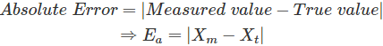  
   Xt is calculated by taking mean of infinite number of measurements.

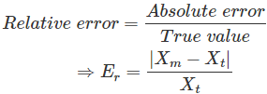

1. Precision: It is defined as the closeness among a set of values. It is different from accuracy. Let Xt be the true value of the variable X and a random experiment measures X1, X2, …. Xi as the value of X. We will say our measurements X1, X2… Xi is precise when they are very near to each other but not necessarily close to true value Xt. However, if we say X1, X2… Xi is accurate, it means that they are close to true value Xt and hence they are also close to each other. Hence accurate measurements are always precise.

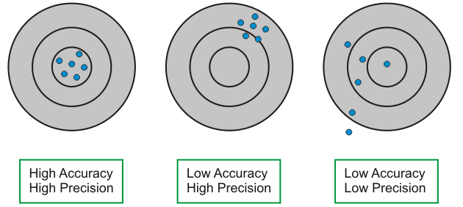

1. Sensitivity: It is the ratio of change in output to change in input. If Y be the output quantity in response to input X, then sensitivity S can be expressed as

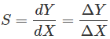

1. Linearity: Linearity is the maximum deviation between the measured values of a sensor from ideal curve.

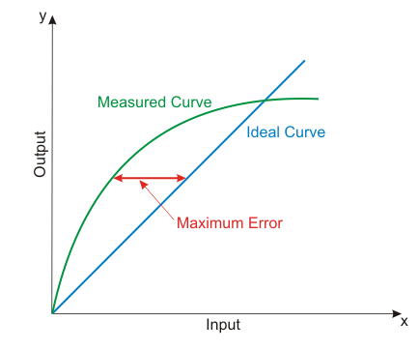

1. Hysteresis: It is the difference in output when input is varied in two ways- increasing and decreasing.

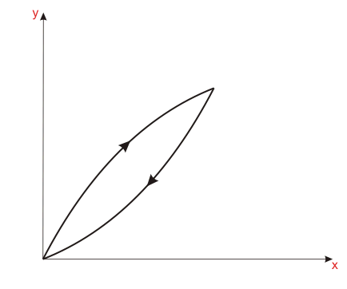

1. Resolution: It is the minimum change in input that can be sensed by the [sensor](https://www.electrical4u.com/sensor-types-of-sensor/).
2. Reproducibility: It is defined as the ability of sensor to produce the same output when same input is applied.
3. Repeatability: It is defined as the ability of sensor to produce the same output every time when the same input is applied and all the physical and measurement conditions kept the same including the operator, instrument, ambient conditions etc.
4. Response Time: It is generally expressed as the time at which the output reaches a certain percentage (for instance, 95%) of its final value, in response to a step change of the input.

**Classification of sensors:**

A sensor is part of a larger system that contains other detectors, memory devices, data recorders, actuators, signal conditioners and signal processors. The general classification of sensors is as follows:

* **Internal/Proprioceptive sensors** (for robot control) that include position sensors, velocity sensors, torque and acceleration sensors
* **External/Exteroceptive sensors** (for robot guidance, obstacle identification, monitoring) that include tactile sensors, force and torque sensors, proximity sensors, range sensors, vision sensors and others

There are several sensors that are designed to determine the location and size of various objects in the world.

1. **Proximity sensors** – detect objects that are closely placed without any point of contact. These sensors can detect the presence or absence of the object by using light, sound or electromagnetic field. Proximity sensors include:

* Infrared sensors
* Ultrasonic sensors
* Photoresistor

1. **Range sensors** – measure the distance between objects in the operation area. Range sensors are used for robot navigation and for avoiding obstacles.
2. **Tactile sensors** – specify the contact between an object and sensor. These sensors are divided in two types, namely:

* Touch Sensor
* Force Sensor

1. **Digital cameras** can, with enough processing power, locate specific objects in their field of view
2. **Pressure Sensors** measures pressure. Tactile pressure sensors are useful in robotics as they are sensitive to touch, force and pressure. If you design a robot hand and need to measure the amount of grip and pressure required to hold an object, then this is what you would want to use.
3. **IMU (**Inertial Measurement Units) combine properties of two or more sensors such as Accelerometer, Gyro, Magnetometer, etc, to measure orientation, velocity and gravitational forces. In simple words, IMU’s are capable of providing feedback by detecting changes in an objects orientation (pitch, roll and yaw), velocity and gravitational forces. Few IMUs go a step further and combine a GPS device providing positional feedback.

**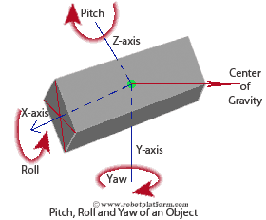**

### ****Voltage Sensors** typically** convert lower voltages to higher voltages, or vice versa. One example is a general Operational-Amplifier (Op-Amp) which accepts a low voltage, amplifies it, and generates a higher voltage output. Few voltage sensors are used to find the potential difference between two ends (Voltage Comparator). Even a simple LED can act as a voltage sensor which can detect a voltage difference and light up. (not considering current requirements here)

### ****Current Sensors**** are electronic circuits which monitor the current flow in a circuit and output either a proportional voltage or a current. Most current sensors output an analog voltage between 0V to 5V which can be processed further using a microcontroller.

### There are hundreds of sensors made today to sense virtually anything you can think of, and it is almost impossible to list all available sensors. Apart from those mentioned above, there are many other sensors used for specific applications.

**ROBOT PARAMETERS**

For the experienced mechanical, electrical engineers in the automation industry, it is probably a simple job to choose the right robot. But for some automation designers or factories who need to purchase or import robots for the first time may be somewhat confused.

The following is about how to choose a suitable industrial robot concerning 9 professional parameters**:**

**1. Application:**

First of all, the most important part is to evaluate what kind of applications and what kind of processes the robots are used for. The [collaborative robot](http://www.evsrobot.com/) (Cobots) should be a good option if the application process needs to be for the usual man-machine closely mixed semi-automatic line, especially the situations which needs changing work position or shifting the line, or are combined with a new torque sensor.  
If you are looking for a well-knit [Pick and Place robot](http://www.evsrobot.com/), you can choose a horizontal joint [Scara robot](http://www.evsrobot.com/" \t "_blank) . Parallel [Delta robots](http://www.evsrobot.com/)  are very suitable for situations in which they need to pick and place small objects quickly. Next, we will discuss the vertical joint [multi axis robot](http://www.evsrobot.com/) (Multi-axis). This robot can adapt to a very wide range of applications. Choose the most suitable model.

**2. Payload:**

The payload is the maximum load that a robot can carry in its work. For example, the payload can be from 3Kg to 1300Kg according to different model types. If you want the robot to carry the target work piece from one working position to another, you need to add the weight of the work piece and the weight of the robot's gripper to its estimated payload requirement. It is also important to note that the load required by the robot is related to the distance of the end load. For example, you can check the load counting drawing method of [SOOYEE Robot SYB1410B](https://www.sooyeerobot.com/product/SYB1410B.html).

**SYB1410B load counting drawing**

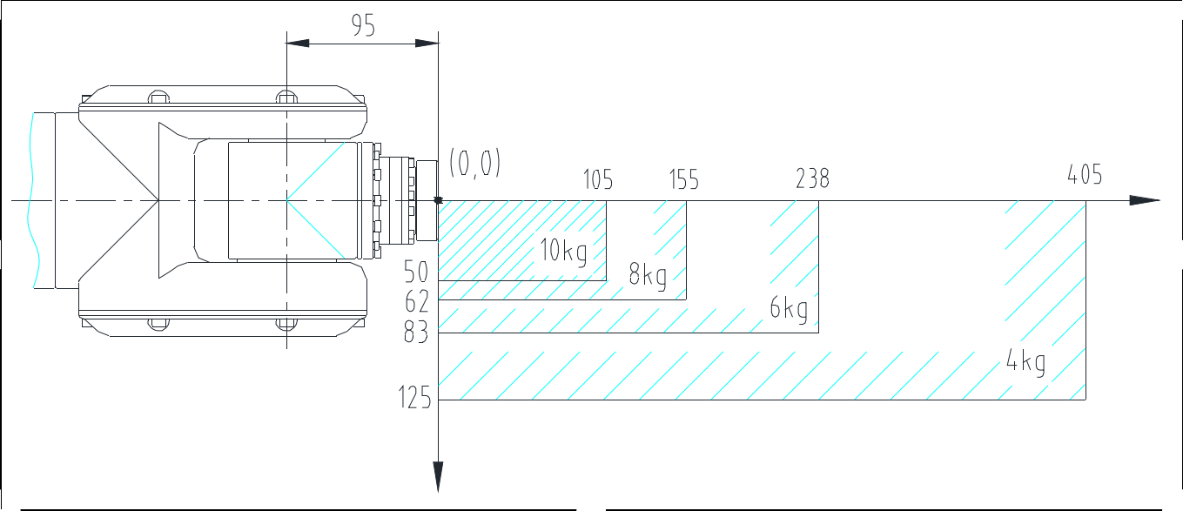

**3. Maximum Operating Range:**

When evaluating a targeting application, you should know the maximum distance the robot needs to reach. [Choosing a robot](http://www.evsrobot.com/)is not solely based on its payload - it also requires a comprehensive consideration of the exact distance it reaches. Each company will give a map of the range of motion of the corresponding robot, from which it can be judged whether the robot is suitable for a particular application. About the horizontal movement range of the robot, please pay attention to a non-working area of the robot in the close and rear place.  
The maximum vertical height of the robot is measured from the lowest point the robot can reach (usually below the base of the robot) to the maximum height (Y) the wrist can reach. The maximum horizontal movement distance is the distance (X) from the center of the robot base to the center of the furthest point that the wrist can reach horizontally.

M-2000iA/2300 Super Heavy Payload Robot made by Fanuc Corporation (JPN).

The MotoMini robot arm has a payload of 0.5 kg, a horizontal reach of 350 mm, and a vertical reach of 496 mm.The KUKA KR 1000 titan 6-axis robot has a total of nine motors, which together deliver the power of a mid-sized car, giving it a payload capacity of 1000 kg. Combined with its reach of 3.2 meters and its ability to withstand a static torque of 60,000 newton meters (Nm)

**4. Degree of Freedom (number of axes):**

The number of axes configured by the [robot](http://www.evsrobot.com/) is directly related to its degree of freedom. If it is for a simple straight-forward operation situation, such as taking from one belt line to another, a simple [4 axis robo](http://www.evsrobot.com/)t is sufficient. However, if the application is in a small working space and the robot arm needs a lot of twisting and turning, a [6 axis robot](http://www.evsrobot.com/) or [7 axis robots](http://www.evsrobot.com/) will be good choice.

**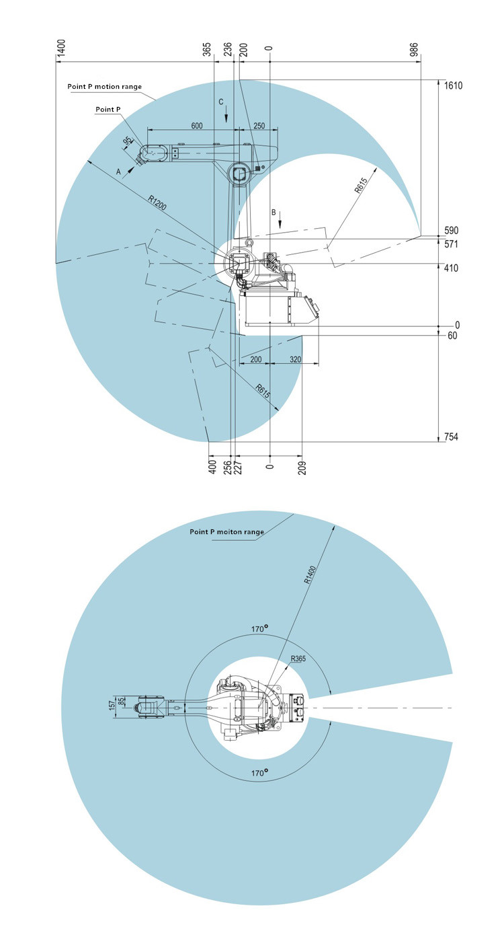**

**5. Repeated Positioning Accuracy**

* This factor also depends on your application. Repeated Positioning Accuracy can be described as the robot's ability to complete routine work tasks each time they reach the same location. Generally between ±0.05mm and ±0.02mm, or even more accurate. For example, if you need your robot to assemble an electronic circuit board, you may need a super precise repeated positioning accuracy robot. If the application process is relatively rough, such as packaging, palletizing, etc., the [industrial robots](http://www.evsrobot.com/) do not need to be so precise in repeated positioning.
* On the other hand, the requirements for robot precision in assembly engineering are also related to the transmission and calculation of the dimensions and tolerances of each process in the assembly engineering, such as the positioning accuracy of the incoming materials and the repeated positioning accuracy of the work piece itself in the fixture. This indicator is expressed as plus or minus '±' from 2D. In fact, since the robot's movement repetition point is not linear but moves in space 3D, the actual condition of this parameter can be anywhere within the spherical space within the tolerance radius.
* Of course, the current motion compensation with machine vision technology will reduce the robot's requirements and dependence on the accuracy of incoming materials and improve the overall assembly accuracy.

**6. Speed:**

* This parameter is closely related to each user. In fact, it depends on the cycle time that the job needs to complete. The specification table shows the maximum speed of the model robot, but we should know that considering the acceleration and deceleration from one point to another, the actual speed will be between 0 and the maximum speed. This parameter is usually expressed in degrees/second. Some robot manufacturers also mark the maximum acceleration of the robot.

**7. Body Weight:**

* The robot body weight is an important factor when designing a robot cell. If an industrial robot must be mounted on a custom machine, even on a guide rail, you may need to know its weight to design the corresponding supporting structure.

**8. Brake and Moment of Inertia:**

* Basically every robot manufacturer provides information about their robotic braking system. Some robots have brakes on all axes. Other [robot models](http://www.evsrobot.com/) do not have brakes on all axes. To ensure an accurate and repeatable position in the work area, you need a sufficient number of brakes. In another special case, when an accidental power outage occurs, the load-bearing robot shaft without brakes will not lock up, causing an accidental risk.
* At the same time, some robot manufacturers also provide the robot's moment of inertia. In fact, this will be an additional guarantee for the safety of the design. You may also notice the applicable torque on different axes. For example, if your action requires a certain amount of torque to perform the job correctly, you need to check if the maximum torque applied on the shaft is correct. If the selection is incorrect, the robot may be shut down due to overload.

**9. Protection level (IP):**

* According to the using environment of the robot, we will need to select a certain degree of protection (IP rating). Some manufacturers provide the same robots with different IP protection grades for different applications. If the robot is working with a food-related product, medicine, medical device, or in a flammable environment, the IP rating will vary accordingly.  For example, SOOYEE robot's IP is **IP54**.

Here is the explain on IP number:

**First number (Protection against solid objects)**

0 No protection  
1 Protected against solids objects over 50mm (e.g. accidental touch by hands  
2 Protected against solids objects over 12mm (e.g. fingers)  
3 Protected against solids objects over 2.5mm (e.g. tools and wires)  
4 Protected against solids objects over 1mm (e.g. tools, wires and small wires  
5 Protected against dust - limited ingress (no harmful deposit)  
6 Totally protected against dust  
  
 **Second number (Protection against liquids)**

0 No protection  
1 Protected against vertically falling drops of water  
2 Protected against direct sprays up to 15o from the vertical  
3 Protected against direct sprays up to 60o from the vertical  
4 Protected against sprays from all directions - limited ingress permitted  
5 Protected against low pressure jets if water from all directions - limited ingress permitted

6 Protected against strong jets of water e.g. for use on ship decks - limited ingress permitted

7 Protected against the effects of temporary immersion between 15cm and 1m. Duration of test 30 minutes.

8 Protected against long periods of immersion under pressure

**10. Compliance**

An industrial robot should not move on the application of an external force. They are provided with a magnetic locking which helps them to stay in same position even a external force is applied on the system.

**Types of Industrial Robots:**

Based on mechanical configuration, industrial robots can be classified into six major types namely: articulated robots, Cartesian robots, SCARA robots, delta robots, polar robots and cylindrical robots. Apart from mechanical configuration, industrial robots can also be categorized based on motion control, power supply control and physical characteristics.

This blog will focus on the major types of industrial robots based on configuration, their advantages and disadvantages and the areas of application.

**Articulated Robots**

Articulated robot is one of the most comment types of industrial robots. It resembles a human arm in its mechanical configuration. The arm is connected to the base with a twisting joint. The number of rotary joints connecting the links in the arm can range from

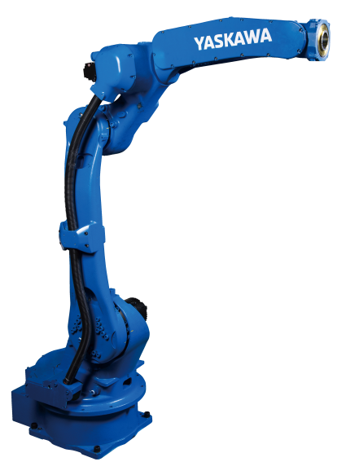 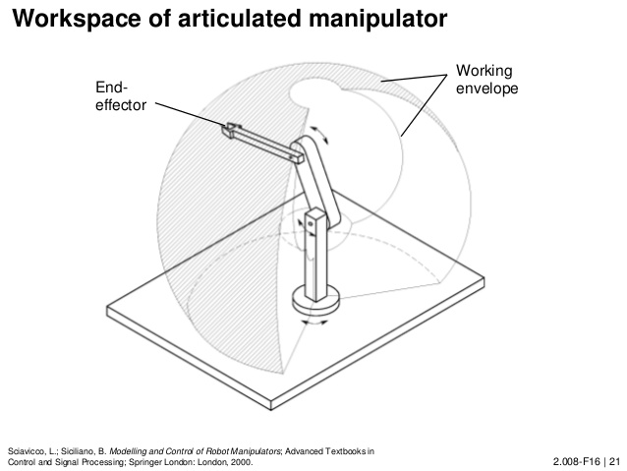

two joints to ten joints and each joint provides an additional degree of freedom. The joints can be parallel or orthogonal to each other. Articulated robots having six degrees of freedom are the most commonly used industrial robots as the design offers maximum flexibility.

**Advantages**

* High speed
* Large work envelope for least floor space
* Easier to align to multiple planes

**Disadvantages**

* Requires dedicated robot controller
* Complicated programming
* Complicated kinematics

**Application**

* Food packaging
* Arc welding
* Spot welding
* Material handling
* Machine tending
* Automotive assembly
* Steel bridge manufacturing
* Steel cutting
* Glass handling
* Foundry and forging application

**Cartesian Robots**

Cartesian robots are also called rectilinear or gantry robots and have a rectangular configuration. These types of industrial robots have three prismatic joints to deliver linear motion by sliding on its three perpendicular axes (X, Y and Z). They might also have an attached wrist to allow rotational movement. Cartesian robots are used in majority of industrial applications as they offer flexibility in their configuration which make them suitable for specific application needs.

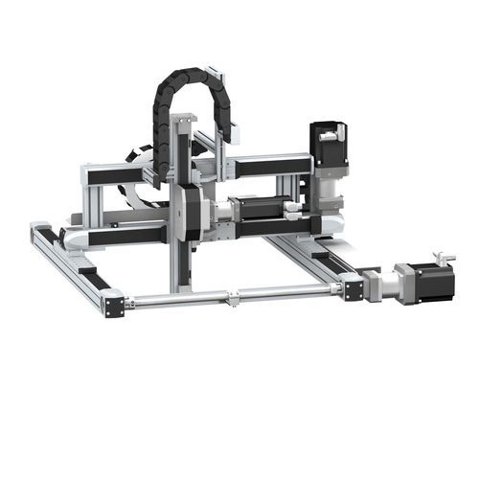 **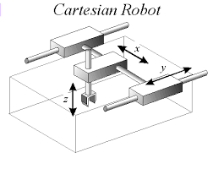**

**Advantages**

* Provides high positional accuracy
* Simple operation
* Easy to program offline
* Highly customizable
* Can handle heavy loads
* Less cost

**Disadvantages**

* Requires large operational and installation area
* Complex assembly
* Movement limited to only one direction at a time

**Application**

* Pick and place operations
* Loading and unloading
* Material handling
* Assembly and sub-assembly
* Nuclear material handling
* Adhesive applications

**SCARA Robots**

A SCARA (Selective Compliance Assembly Robot Arm) robot has a donut shaped work envelope and consists of two parallel joints that provide compliance in one selected plane. The rotary shafts are positioned vertically, and the end effector attached to the arm moves horizontally. SCARA robots specialize in lateral movements and are mostly used for assembly applications. The SCARA robots can move faster and have easier integration than cylindrical and Cartesian robots.

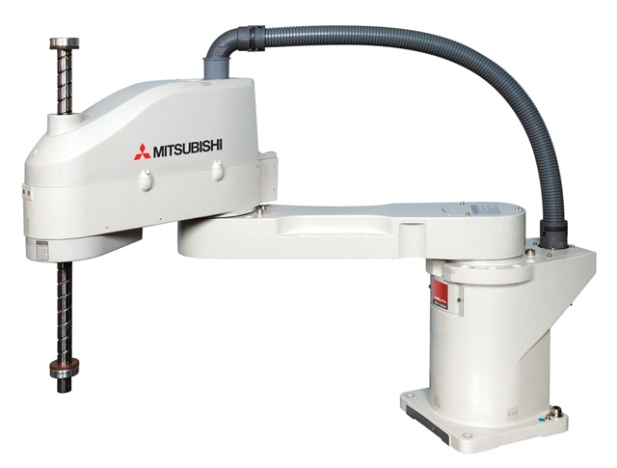 **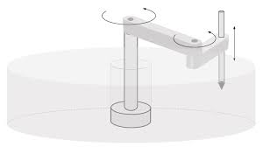**

**Advantages**

* High speed
* Excellent repeatability
* Large workspace

**Disadvantages**

* Requires dedicated robot controller
* Limited to planar surfaces
* Hard to program offline

**Application**

* Assembly applications
* Semiconductor wafers handling
* Biomed applications
* Packaging
* Palletizing
* Machine loading

**Delta Robots**

Delta robots are also called parallel link robots as it consists of parallel joint linkages connected with a common base. Owing to direct control of each joint over the end effector, the positioning of the end effector can be controlled easily with its arms resulting in high speed operation. Delta robots have a dome shaped work envelope. These robots are generally used for fast pick-and-place or product transfer applications.

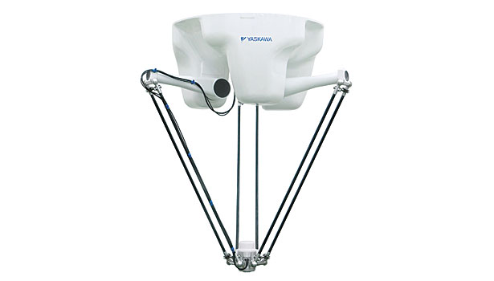 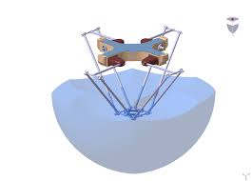

**Advantages**

* Very high speed
* High operational accuracy

**Disadvantages**

* Complicated operation
* Requires dedicated robot controller

**Application**

* Food industry
* Pharmaceutical industry
* Electronic industry
* Flight simulators
* Automobile simulators
* Optical fiber alignment

**Polar Robots**

Polar robots have a twisting joint connecting the arm with the base and a combination of two rotary joints and one linear joint connecting the links. These are also called as spherical robots, since it has a spherical work envelope and the axes form a polar co-ordinate system. These robots have a centrally pivoting shaft and an extendable rotating arm. The gun turret configuration of polar robots sweeps a large volume of space, but the access of the arm is restricted within its workspace.

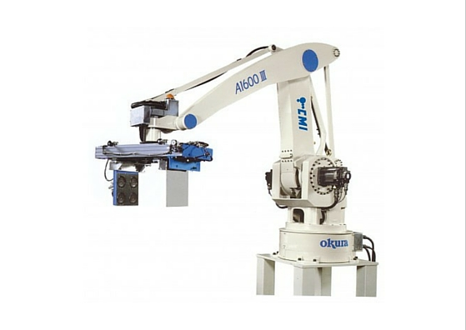 **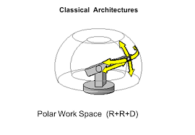**

**Advantages**

* Can reach all around
* Can reach above or below obstacles
* Large work volume
* Requires less floor space

**Disadvantages**

* Cannot reach above itself
* Short vertical reach
* Low accuracy and repeatability in direction of rotary motion
* Requires sophisticated control system
* Fallen out of favor and not common in new designs

**Application**

* Die casting
* Glass handling
* Stacking and unstacking
* Injection molding
* Forging
* Welding
* Material handling

**Cylindrical Robots**

Cylindrical robots have at least one rotary joint at the base and at least one prismatic joint connecting the links. These robots have a cylindrical workspace with a pivoting shaft and an extendable arm which moves vertically and by sliding. Thus, robots with cylindrical configuration offers vertical and horizontal linear movement along with rotary movement about the vertical axis. The compact design of the end of the arm allows the robot to reach tight work envelopes without any loss of speed and repeatability. It is mostly used in simple applications where materials are picked up, rotated and placed.

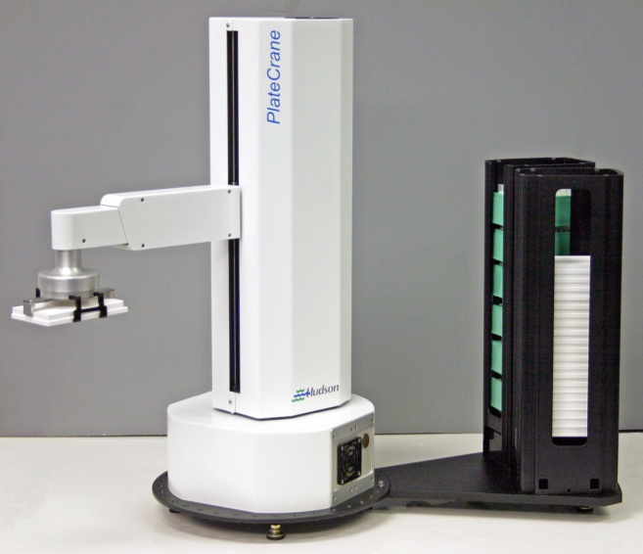 **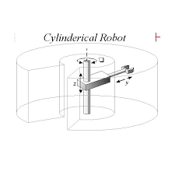**

**Advantages**

* Simple operation and installation
* Minimal assembly
* Can reach all around itself
* Requires less floor space
* Can carry large payloads

**Disadvantages**

* Cannot reach around obstacles
* Low accuracy in direction of rotary motion
* Fallen out of favor and not common in new designs

**Application**

* Transport of LCD panels
* Assembly applications
* Coating applications
* Die casting
* Foundry and forging application
* Machine loading and unloading

**Robot coordination system**

**Cartesian co-ordinates:**

Cartesian coordinate system is a system that uniquely specifies each point in plane by a pair of numerical coordinates, i.e. the signed distances to the point from two fixed perpendicular directed lines. Each reference line is known as the coordinate axis and the point where they meet is known as its origin (0, 0).

**TOOL COORDINATE SYSTEM**: Tool coordinate system is freely definable. The origin of the tool coordinate system is called the Tool Center Point (TCP) and is used for tools.

**WORLD COORDINATE SYSTEM**: World Coordinate System in most cases is located in the robot base. World coordinate system is freely definable and uses the origin of Robot & Base. It uses the Cartesian coordinate system i.e. X, Y, Z plane to define the Translational Motion of the robot axes & A, B, C to define the Rotational Motion of the robot axes with regards to the translational motion of the robot axes where X//C, Y//B, Z//A.

**INTRODUCTION TO ROBOT WELDING TECHNOLOGY**

Welding is a technology that provides the fastest, strongest, and most economical method of joining metals. The field of welding has moved from coal-fired furnaces and hammers used for forging iron, to modern methods such as the concentrated accelerated free electrons of the electron beam process and the advantages of robots and lasers. Welding had its ancient origins in the fires of blacksmiths, who could forge two white-hot pieces of metal together with hammer blows and patience Preliminary, the simple definition of welding was “joining metals through heating them to a molten state and fusing them together.” With increasing progress in welding processes and techniques, the definition has had to change. It is quite true to say that the weld is stronger than the base metal. Beside the classic application areas of welding such as shipbuilding, automobile manufacturing, building construction, and pipelines, currently welding techniques are being used in more complex application fields including aircraft, space vehicles, and nuclear reactors.

Conventionally, arc welding and oxyacetylene fuel welding were two main welding techniques but currently more modern technologies are being used such as pulsed GTAW, plasma welding and cutting, submerged arc, pulsed GMAW, and electron beam and laser welding. Basically, there are two types of welding namely, fusion and non-fusion. The former is the most common and involves the actual melting of the parent metals being joined. Non-fusion welding is most commonly represented by soldering and brazing where the parent metal is heated, but not melted, and a second or “filler” metal is melted between them, forming a strong bond when all are cooled

**History of welding**

The earliest evidence of welding can be traced back to the Bronze Age. The earliest examples of welding are welded gold boxes belonging to the Bronze Age. The Egyptians also learnt the art of welding. Several of their iron tools were made by welding. During the middle Ages, a set of specialized workmen called blacksmiths came to the fore. Blacksmiths of the middle Ages welded various types of iron tools by hammering. The welding methods remained more or less unchanged until the dawn of the 19th century. In the 19th century, major breakthroughs in welding were made. The use of open flames (acetylene) was an important milestone in the history of welding since open flames allowed the manufacture of intricate metal tools and equipment. Englishman Edmund Davy discovered acetylene in 1836 and acetylene was soon utilized by the welding industry. In 1800, Sir Humphrey Davy invented a battery operated tool which could produce an arc between carbon electrodes. This tool was extensively used in welding metals. In 1881, French scientist Auguste De Meritens succeeded in fusing lead plates by using the heat generated from an arc. Later, Russian scientist Nikolai N. Benardos and his compatriot Stanislaus Olszewski developed an electrode holder for which they secured US and British patents.

During the 1890's, one of the most popular welding methods was carbon arc welding. Around the same time, American C.L. Coffin secured a US patent for metal electrode arc welding. N.G. Slavianoff of Russia used the same principle for casting metals in molds. Coated metal electrode was first introduced in 1900 by Strohmenger. A coating of lime helped the arc to be much more stable. A number of other welding processes were developed during this period. Some of them included seam welding, spot welding, flash butt welding, and projection welding. Stick electrodes became a popular welding tool around this time as well.

After the end of World War I, the American Welding Society was established by Comfort Avery Adams. The aim of the society was the advancement of welding processes. CJ Holstag also invented the alternating current in 1919. However, alternating current was first commercially utilized by the welding industry only in the 1930's.Automatic welding was first introduced in 1920. Invented by P.O. Nobel, automatic welding integrated the use of arc voltage and bare electrode wires. It was used for repairing and molding metals. Several types of electrodes were also developed during this decade.

The New York Navy Yard developed stud welding. Stud welding was increasingly used for the construction industry and also for shipbuilding. It was during this time that the National Tube Company developed a welding process called smothered arc welding. In the sector of shipbuilding, the stud welding process was replaced by the more advanced submerged arc welding. A new type of welding for seamlessly welding aluminum and magnesium was developed in 1941 by Meredith. This patented process came to be known as Heliarc welding. The gas shielded metal arc welding or GTAW was another significant milestone in the history of welding which was developed in Battelle Memorial Institute in 1948.The CO2 welding process popularized by Lyubavskii and Novoshilov in 1953 became a welding process of choice for welding steels, as it was comparatively economical. Soon, electrode wires of smaller diameter were launched. This made welding of thin materials more convenient. There were several advancements in the welding industry during the 1960's. Dual shield and Inner shield welding and Electro slag welding were some of the important welding developments of the decade. Plasma arc welding was also invented by Gage during this time. It was used for metal spraying. The French also developed electron beam welding, which is still used by the aircraft manufacturing industries of the United States.

Some of the recent developments in the welding industry include the friction welding process developed in Russia, and laser welding. Laser was originally developed in Bell Telephone Laboratories but it is now being used for various kinds of welding work. This is due to the inherent capacity of lasers in rendering precision to all kinds of welding jobs. Friction welding, which uses rotational speed and upset pressure to provide friction heat, was developed in the Soviet Union. It is a specialized process and has applications only where a sufficient volume of similar parts is to be welded because of the initial expense for equipment and tooling. This process is called inertia welding.

Laser welding is one of the newest processes. The laser was originally developed at the Bell Telephone Laboratories as a communications device. Because of the tremendous concentration of energy in a small space, it proved to be a powerful heat source. It has been used for cutting metals and nonmetals. Continuous pulse equipment is available. The laser is finding welding applications in automotive metalworking operations. Recently, Magnetic Pulse Welding (MPW) is introduced by Pulsar Ltd. of Israel using capacitive power as a solid state welding process. Discharging 2 million amps in less than 100 microseconds this process can create a metallurgical, a non-metallurgical or a mechanical lock, depending on the substrate involved. No heat affected zone (HAZ) is created since only a rise of 30°C occurs.

There have been more innovations in welding during the last 50 years and with the invention of the laser, using a laser beam to do welding has become popular in automated plants. There have also been many safety improvements as well and the tools, equipment and protective clothing now make welding a very safe activity

**Welding robots**

Industrial Robotic Welding is by far the most popular application of robotics worldwide [7]. In fact, there are a huge number of products that require welding operations in their assembly processes. The car industry is probably the most important example, with the spot and MIG/MAG welding operations in the car body workshops of the assembly lines. Nevertheless, there are an increasing number of smaller businesses, client oriented, manufacturing small series or unique products designed for each client. These users require a good and highly automated welding process in a way to respond to client needs in time and with high quality. It is for these companies that the concepts of Agile Production apply the most, obviously supported by flexible manufacturing setups (Figure 1). Despite all this interest, industrial robotic welding evolved slightly and is far from being a solved technological process, at least in a general way. The welding process is complex, difficult to parameterize and to effectively monitor and control [10-14]. In fact, most of the welding techniques are not fully understood, namely the effects on the welding joints, and are used based on empirical models obtained by experience under specific conditions. The effects of the welding process on the welded surfaces are currently not fully known. Welding can in most case (i.e. MIG/MAG welding) impose extremely high temperatures concentrated in small zones. Physically, that makes the material experience extremely high and localized thermal expansion and contraction cycles, which introduce changes in the materials that may affect its mechanical behavior along with plastic deformation

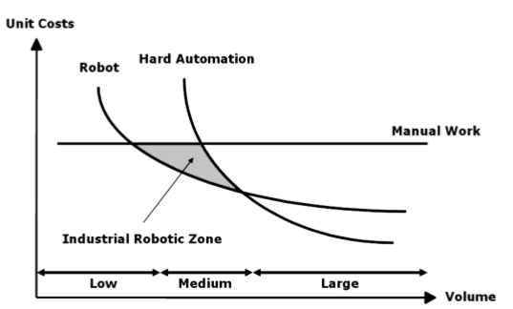

**Figure 1. Industrial robot zone**

Those changes must be well known in order to minimize the effects. Using robots with welding tasks is not straightforward and has been a subject of various R&D efforts [18-22]. And that is so because the modern world produces a huge variety of products that use welding to assemble some of their parts (Figure 2). If the percentage of welding connections incorporated in the product is big enough, then some kind of automation should be used to perform the welding task. This should lead to cheaper products since productivity and quality can be increased, and production costs and manpower can be decreased [23]. Nevertheless, when a robot is added to a welding setup the problems increase in number and in complexity. Robots are still difficult to use and program by regular operators, have limited remote facilities and programming environments, and are controlled using closed systems and limited software interfaces

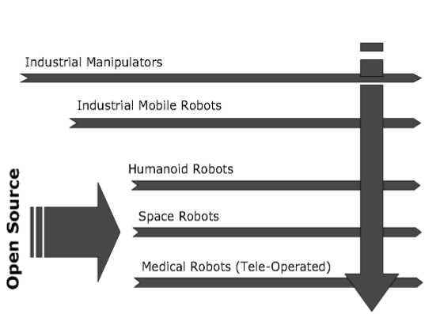

**Disadvantages of welding robots**

Despite the advantages of using a robotic welder, they also present a few concerns. Robotic welders are expensive to purchase, which means that an average business cannot afford one. They require trained personnel to man and program and can often break down or need repair. Other concerns are that the limited movement of a robotic arm might not allow the robot to weld all necessary places. This means that a human welder will still have to go in and finish the job. If the object needing to be welded has been placed incorrectly, the welding robot will still weld in exactly the same programmed places, so that the welds are "off" or located in the wrong place. Poor programming can also produce inaccurate results. Robots are also limited to only a few types of welding, and many of these take longer to cool or can even weaken metal if not used properly

**Automated welding**

Rectilinear robots move in line in any of three axes (X, Y, and Z). In addition to linear movement of the robot along axes there is a wrist attached to the robot to allow rotational movement. This creates a robotic working zone that is box shaped. Articulating robots utilize arms and rotating joints. These robots move like a human arm with a revolving wrist at the end. This creates an irregularly shaped robotic working zone known as the work arc.

There are many factors that need to be considered when setting up a robotic welding facility. Robotic welding needs to be engineered differently than manual welding. Some of the considerations for a robotic welding facility are listed below:

* The selected welding programs include start / stop, gas pre flushing, electrode feed and nozzle flushing. Robots have been used about 15 years to weld complete automotive body assembly and sub assembly components. In general equipment for automatic arc welding is designed differently from that used for manual arc welding. Automatic arc welding normally involves high duty cycles, and the welding equipment must able to operate under those conditions. In addition, the equipment components must have the necessary features and controls to interface with the control system. The number of items of any one type to be welded must be high enough to justify automating the process. If the joints are to be welded on a work piece are few, straight and easily accessible, a rack automatic gas metal gas welding (GMAW) gun or gas tungsten arc welding (GTAW) torch may be suitable for key welds.
* An automatics gun also can be used in a fixed position or on a curved track for a curved or circular weld such as joining two pieces of pipes or welding a flat base to a cylindrical shape—a task in which a work piece can be rotated past the gun. If parts are normally need adjustment to fit together correctly, or if joints are to be welded, they are too wide or different positions from piece to piece, automating the procedure will be difficult or impossible. The tabletop size robot is used to maximum effect- welding work piece is one side of a revolving jig. Each side of jig also can be revolved to allow access to both sides of work piece. Robots work well for repetitive tasks on similar pieces that involve welds in more than one axis or where access to the piece is difficult. Welding robots are used in two ways in manufacturing – as elements in production line and as stand-alone units for batch production. Few companies move from all manual welding to a completely automated production line, so many people introduce robotic welding with a standalone cell.
* At fabrication or welding trade shows, a variety of welding robots can be seen performing complex maneuvers and elegant pirouettes similar to troupe ballet dancers. These displays are designed to demonstrate the speed and flexibility of today’s generation of robots. The fact is, dance moves aside, today’s robots can handle a wide range of welding applications. Some of the welding operations that can be performed by robots are as follows:

1. Arc welding
2. MIG welding
3. TIG welding
4. Spot welding
5. Stick welding

**YASKAWA MA3120**

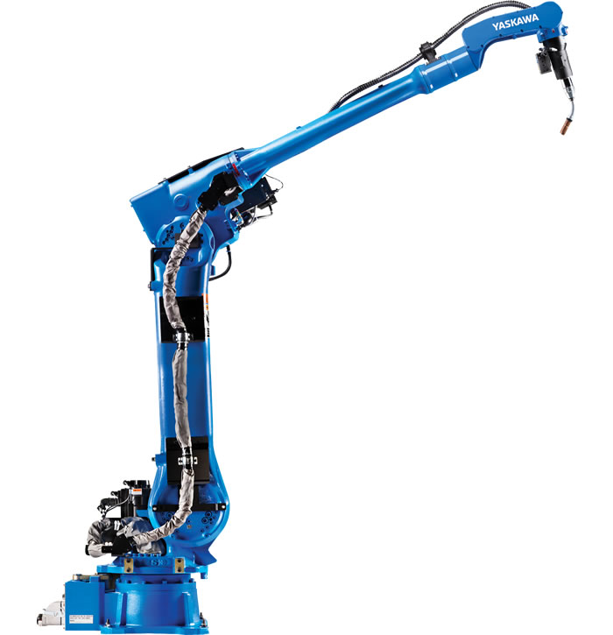

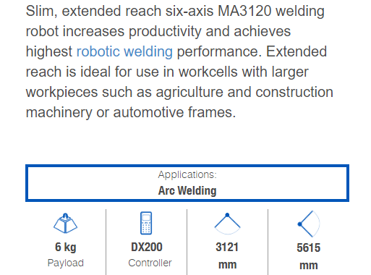

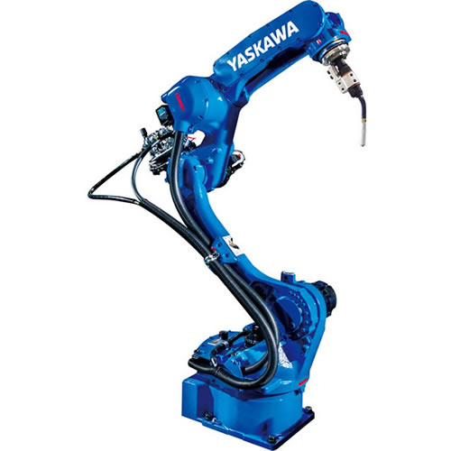 **AR1440 BY YASKAWA**

The six-axis AR1440 robot provides fast and accurate performance to boost productivity for arc welding applications. A slim profile allows for high-density robot placement, and a contoured arm gives easy access to parts in confined spaces, avoiding potential fixture interference. It has a symmetric wrist, with a generous range, providing equal torch access to both sides of a part. A 50 mm thru-hole reduces cable interference and wear, and an enhanced feeder mounting area on the arm reduces equipment obstruction.

Applications:

Arc Welding

 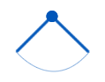

12 kg 1440 mm

Payload Horizontal Reach

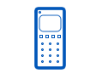 

YRC1000 2511 mm

Controller Vertical Reach

**Short Processing**

Increase freedom in operation or compact and slim design have made the new robots more optimized for specific applications. High-density installation has contributed customer production line saving space. The facility which enables integrated process, rapid production and saving space is called "short processing".

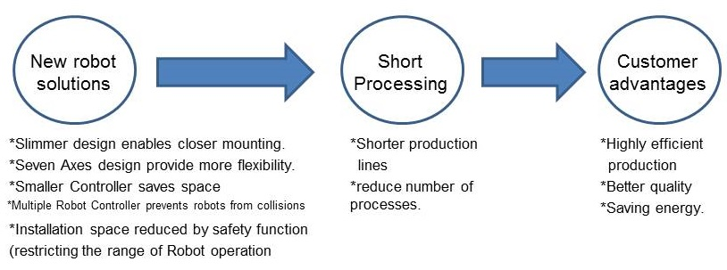

**Save Space and Energy**

Structures, performance and functions designed for optimum application help you to downsize production facilities and save energy.

**Easily avoid interference**

With the 7th axis (E-axis), the arm can easily avoid interference with workpieces and jigs as well as keep the optimal torch posture by going around to the back of work pieces. Large workpieces can be handled and welding can be done the workpiece.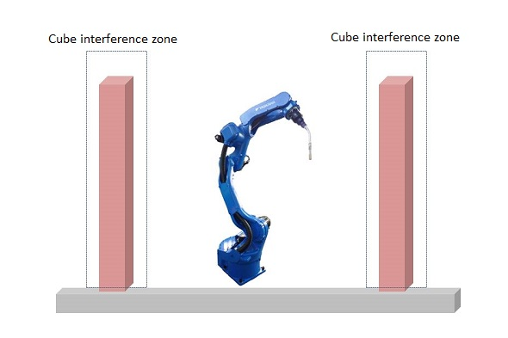

**Use 50% less space with high density layout**

With the robot on shelf or on the top of the positioner, welding can start from the top of the workpiece, and the installation space can be halved. If the robots are in close proximity, the arms can be easily posed to avoid interreference, and several robots can be placed in small space.

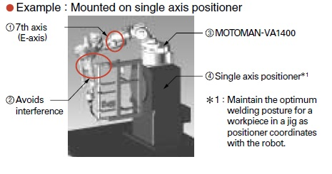

**Increase operability and maintainability with built-in cables**

Not only are the torch cables inside the U-arm, but the welding earth cable as well as the gas and air hoses are inside the base. This reduces the space in which the cables can move and stretches the cable's life.

**Reduced power consumption helps lower running costs**

The servos are turned OFF automatically when the Robot is stopped for long period of time.

Twenty four hour operation in which Robot is operating for 16 hours and on stand by for 8 hours

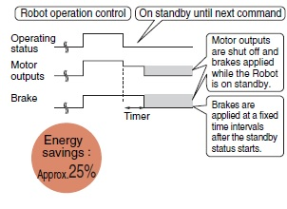

**Basic Robotic Arc Welding Setup**

**Welding positioned:**

A welding positioned is a device that rotates around a 360° spin that allows a welder to stand in one position and constantly work on a level surface. It adds comfort for the welder who must perform on odd shaped parts, such as tubular pipelines.

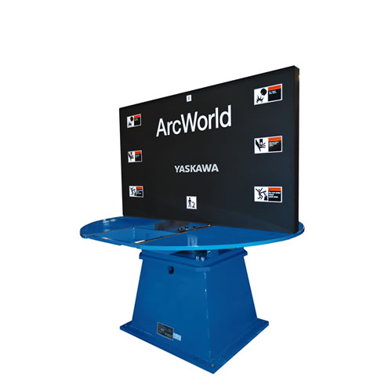

**Robot Controller:**

A controller is a device which takes one or more inputs and adjusts its outputs so a connected device functions in a controlled manner. We offer a wide range of controllers from simple motor controllers to advanced microcontrollers that can be tasked with multiple control outputs and perform closed-loop control.

Various Robot Controllers are

* [DX100](https://www.motoman.com/getmedia/823e83c4-8db7-4a4f-aca7-fc108a5fba47/dx100_controller.pdf.aspx)
* [MLX100](https://www.motoman.com/getmedia/1a3e4935-aef0-4103-86f7-ca575e20166a/mlx100_robot_gateway.pdf.aspx)
* [NX100](https://www.motoman.com/getmedia/a9c00d32-73c1-423d-ad4c-064081b1f39f/NX100_Controller.pdf.aspx)
* [XRC](https://www.motoman.com/getmedia/6e284da6-f2d1-453d-8fc9-2644bd4e101b/xrc_controller.pdf.aspx)

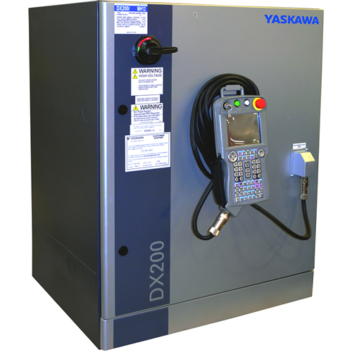

**Welding Peripherals:**

Peripherals are any equipment integrated into the robotic welding process with the objective of maximizing its effectiveness and protecting the overall equipment investment. In short, these devices (in most cases) can add significantly to the ROI a company achieves with its welding robot.

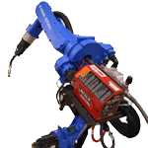

[**Welding Sensors**](https://www.motoman.com/getmedia/db1a69ce-564d-4158-9b05-eefdbf642a8d/AccuFastII.pdf.aspx)

**AccuFast II:**

AccuFast II is compact, mounted in-line with the welding torch and is compatible with YaskawaMotoman’s industry-leading MA- and VA-seriesthru-arm robots, as well as standard 6-axis robots.• Can be combined with ComArc thru-arc seam tracking for contoured parts or long seams that may distort while welding.• The sensor uses the same input and output signals as traditional touch sense, allowing it to be easily retrofitted into existing robot installations. Touch sensing option can be combined with AccuFast II to detect joints that may have optic interference.• Macro Job routines are provided for:- 1D touch- 1D normal touch- 2D touch with lap height control- Edge search (scans across part until signal changes for edge)- 3 pt circle search (inside or outside diameter, check for circle diameter)- Other joints can be detected by adding results of multiple searches• Standard software routines to easily define Tool Center Point (TCP) for torch and laser sensor:- AccuFast TCP macro job- Torch TCP function• Optional devices to check and maintain Tool Center Point (TCP) for the torch and laser sensor:- Laser target

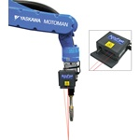

**INTRODUCTION TO ROBOT SIMULATION SOFTWARE**

**Motosim EG**

Motosim EG (Motoman Simulator Enhanced Graphics) is a comprehensive software package that provides accurate 3D simulation of robot cells. This powerful simulation software can be used to optimize robot and equipment placement, as well as to perform collision detection, reach modeling and cycle calculations. It also provides accurate offline programming of complex systems.  
Motosim EG reduces programming time, thus increasing the uptime of the production equipment. New parts can be programmed offline before production begins, and existing robot programs can be modified to increase efficiency and reduce cycle time – without sacrificing production schedules.

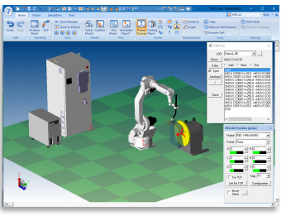

**Hardware Requirements**

When simulate follow situation, PC with high-end CPU or graphic board may need.

• Many robots are used.

• High-capacity CAD data is used.

• Collision check is used.

**Environment Required for Motosim EG**

To run Motosim EG, the following hardware and software are required:

* Microsoft Windows 10 (64bit) OR Microsoft Windows 7 ServicePack1 (32bit / 64bit)
* CPU Intel ® Core TM 2 Duo or more multi-core processor.
* Memory 2 GB or more & Hardware Disk 1 GB or more

Monitor Supported by MS-Windows (256 colors or more)

**Hardware Key:**

For proper operation, connect provided hardware lock key (USB type) to the personal computer before using this software. Check and execute <Checking the computing environment> <Installing the driver> before connecting the key to USB port.

<Checking the computing environment>

Multi-connection of USB type key is not available for one USB port because of hardware structure. Therefore, only one key can be connected to one USB port. When installing multiple offline software into one personal computer and multi-connecting USB keys, use the personal computer which is provided same numbers of USB ports as the number of software to be installed.

<Installing the driver> Execute "\Sentinel Driver\Sentinel System Driver Installer 7.5.9.exe" of installation CD-ROM.

Refer to"\Sentinel Driver\Manual\Sentinel System Driver ReadMe.pdf" for the details of installation..

**Installing Motosim EG**

* It is strongly recommended that you exit all applications before running the setup pro-gram.
* It is strongly recommended that you exit all applications before running the setup pro-gram.
* Follow the on-screen instructions.
* When the setup is completed, {Motosim EG} is registered under the {Motosim EG} folder that appears by clicking the [Start] button in the task bar and selecting {Program}and then {Motoman}. (In the case of Windows10, all menu appears directly under [Motoman].)
* Connect the hardware key to the printer port.
* For details, refer to " 1.4 Hardware Key " in this chapter.

**Programming Languages for Industrial Robots**

* Task in plain English
* Variable Assembly Language
* Epson RC+
* Inform III
* ROBOFORTH

**ROBOT INTERPOLATION TYPES:**

Interpolation type determine the path along which the manipulator moves between playback steps

1. Joint interpolation
2. Linear interpolation
3. Circular interpolation
4. Spline Interpolation
5. **Joint interpolation:**

All joints that require movement start simultaneously and stop simultaneously Robot will attempt to achieve simultaneous start and stop by setting the speed of motion along each axis proportional to the distance to be traveled.

Represented by ‘MOVEJ’

1. **Linear interpolation:**

Regardless of robot configuration, the robot attempts to achieve a linear line while maintaining the tool orientation.

Linear interpolation can be difficult for a non-Cartesian robot. In order to maintain a straight line, the speed of the joints must vary along the path. Therefore, a non-Cartesian robot supports linear interpolation can cost more than a PTP robot. The speed specified by the percentage of maximum speed. Linear interpolation is useful in insertions, machine loading, arc welding, machining, etc.

Represented by ‘MOVEL’

1. **Circular interpolation:**

In circular interpolation, robot will achieve a circular motion while maintain the tool orientation. In addition to the end point, you may have to specify a middle point. Useful in assembly, arc welding, deburring, dispensing, etc.

Represented by ‘MOVEC’

1. **Spline interpolation:**

It is mostly used when the workpieces shape is irregular, and the path of motion is parabola passing through three points.

Represented by ‘MOVES’.

JUMP- To jump to the required line in the program

INC - To take a count

\*NAME- While using jump this is used to carry the work forward to the required position.

SET - To set the count to zero.

TIMER - To set the time for work (i.e., delay or gap)

HIBANA – For spark visibility

ARC ON & ARC OFF – To set the arc on and to off it.

**STEPS INVOLVED IN DESIGNING ARC WELDING APPLICATION ALONG WITH CONVEYOR USING SEQUENCE CONTROL**

1. **Open the Motosim EG software by simple double clicking on the icon**

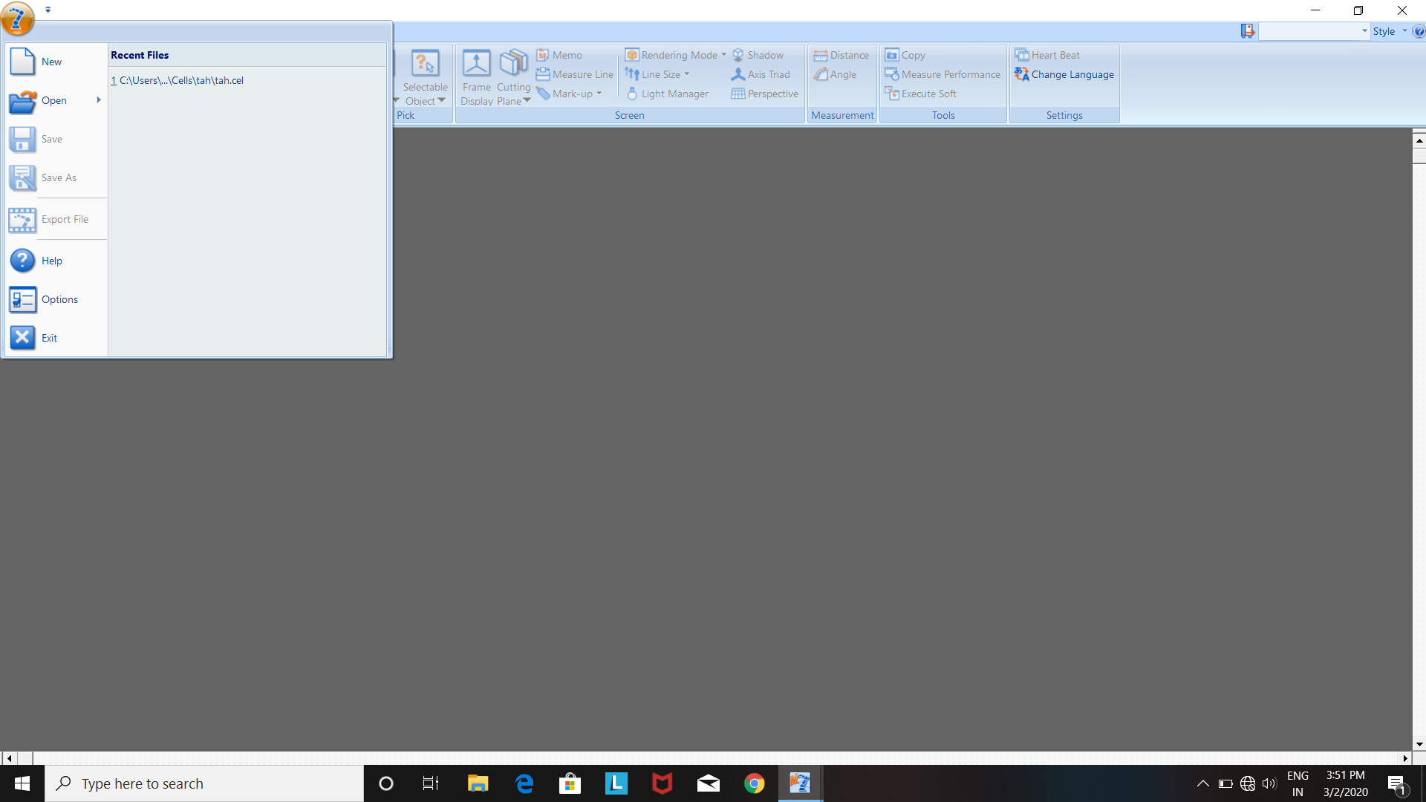

1. **To create a new file click on the top right corner and select new file to create a new Cell.**

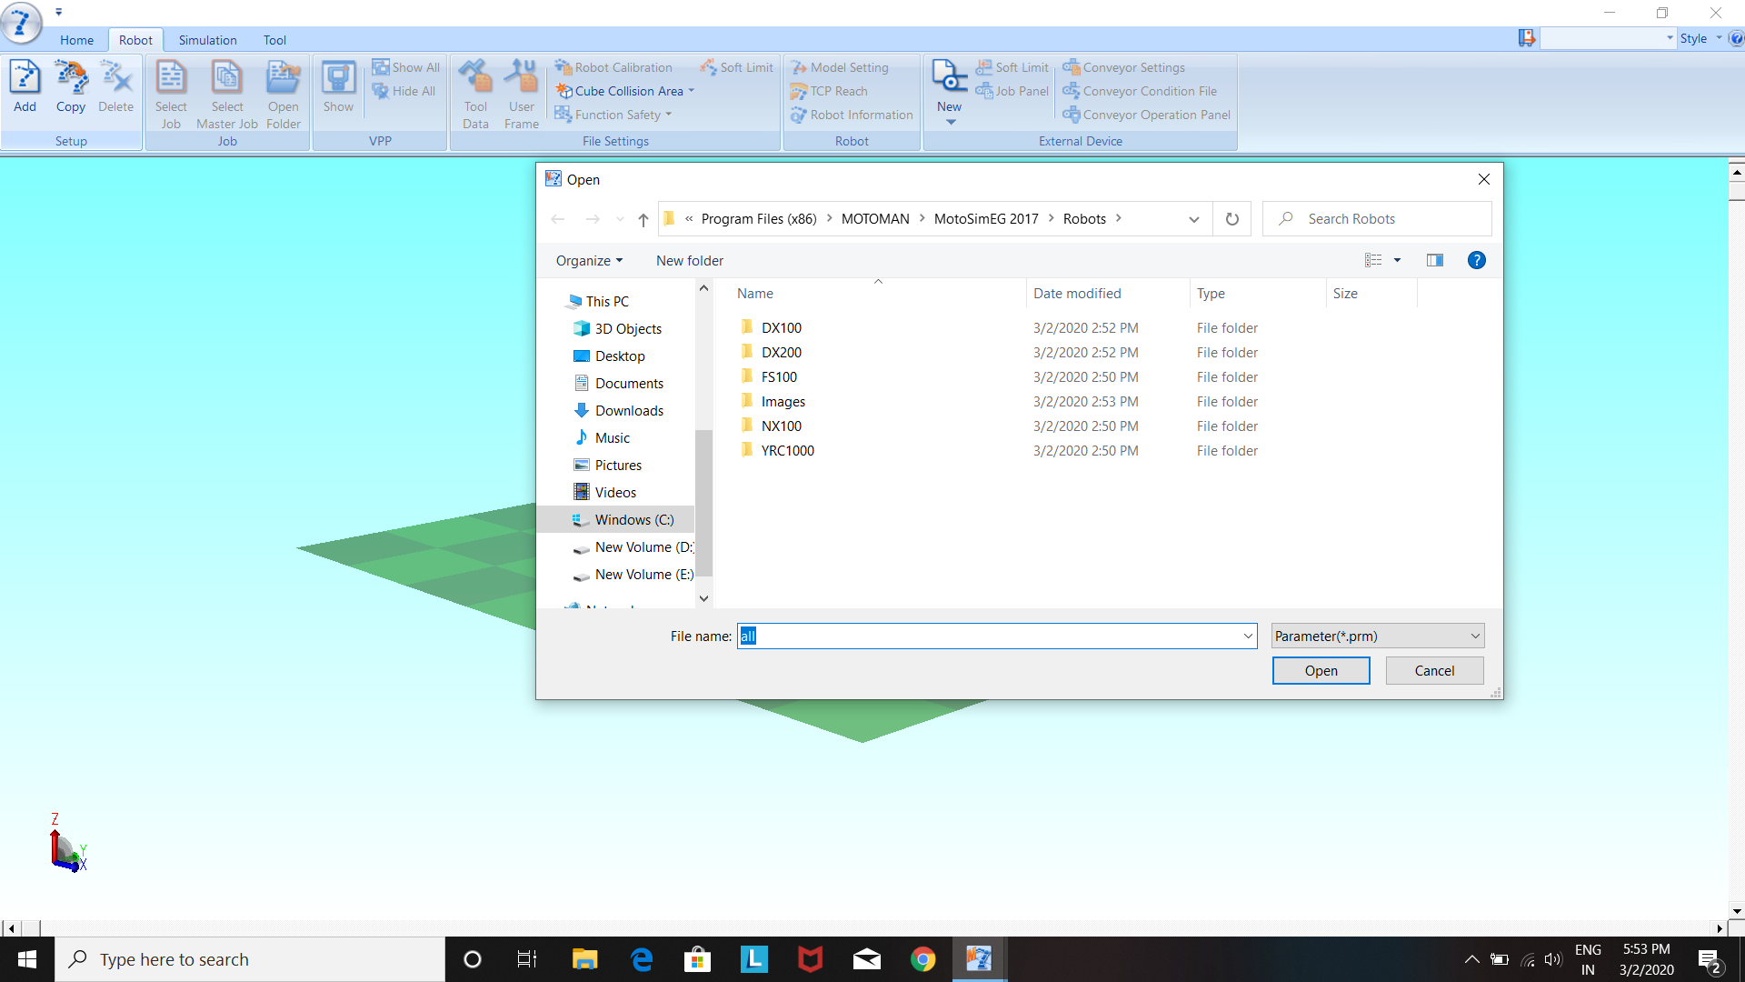

1. **Click on the robot toggle a dialogue box appears as shown in the above figure choose the controller type (DX200) which we generally use and then select the robot series as preferred based on the usage(i.e., MH for material handling).**

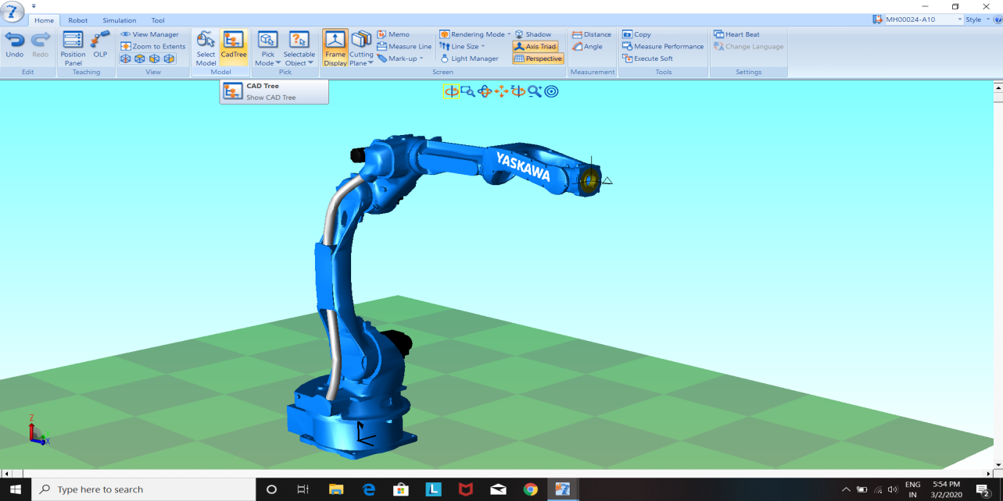

1. **Click on the CADTREE option which shows the cad tree indicating models display status and relationship, can be used to add models or edit models.**

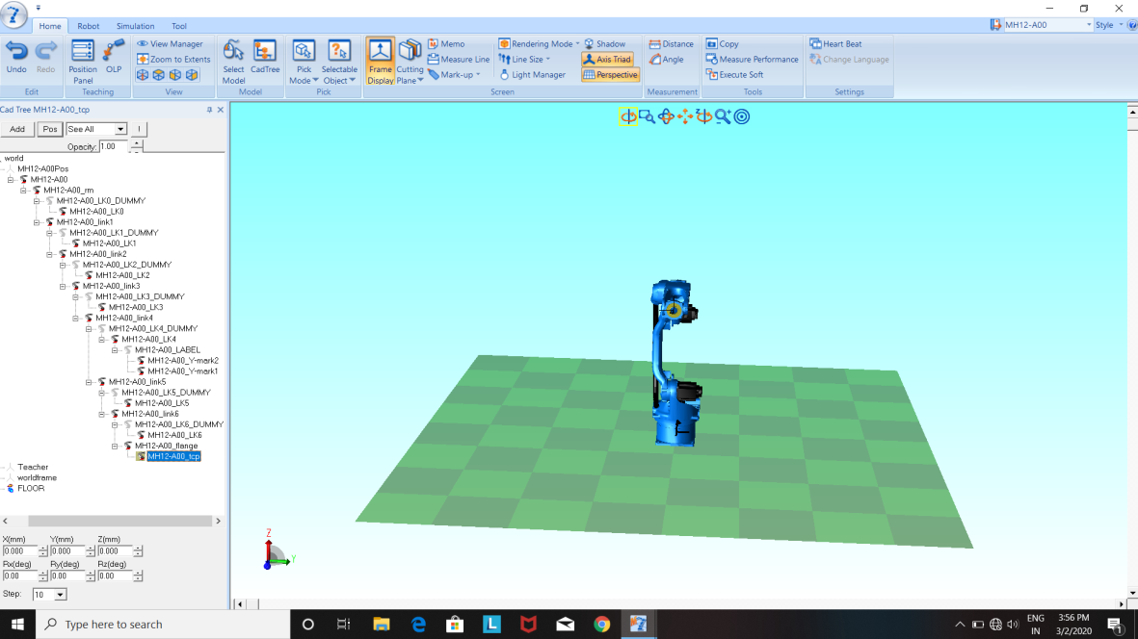

**The dialogue box which appears on the right side is the CADTREE**

1. **If you wish to add another robot then you proceed in the same process above by changing the name of the robot.**

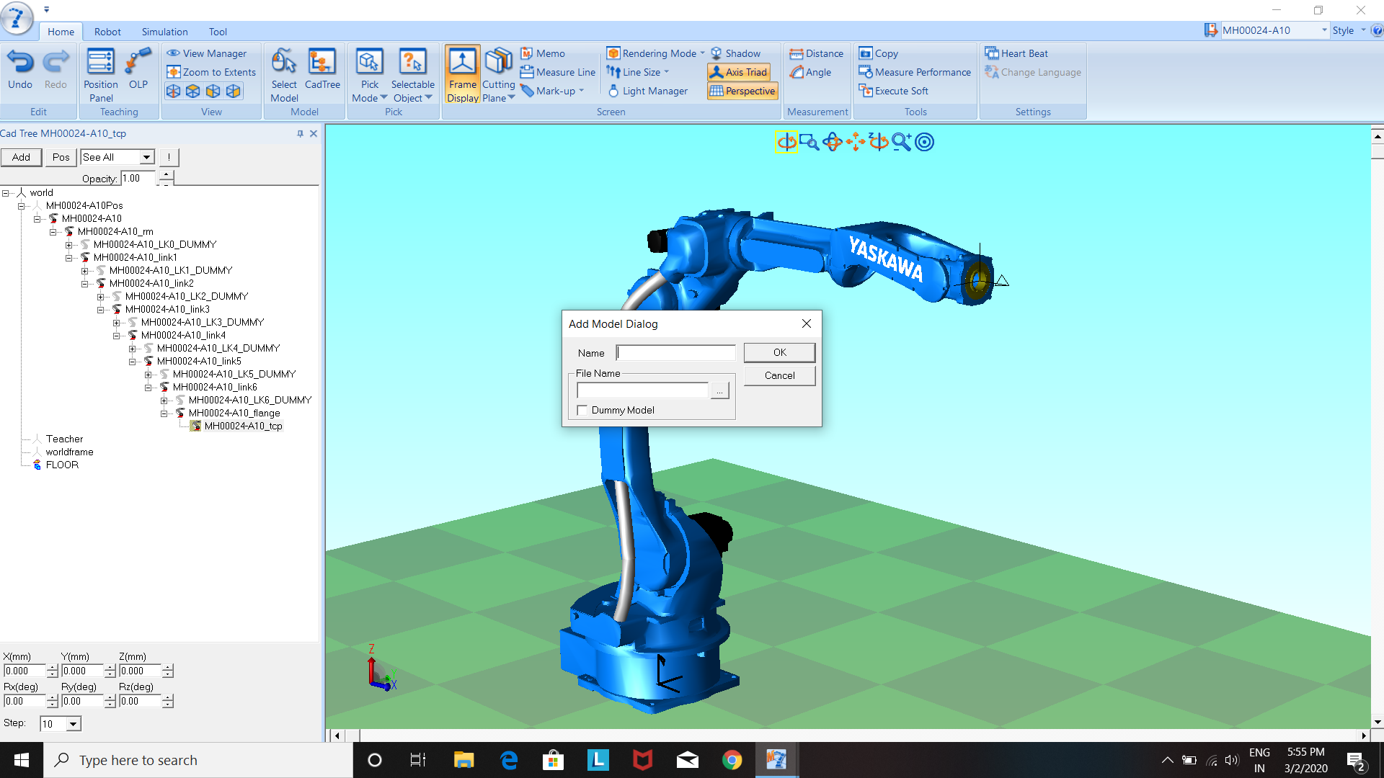

**To add a tool select the TCP in the cad tree and then click on the add button above the CADTREE and choose a file in the below path:** program files > motorman > models > torch > select torch size and click ok and rename the torch; hence torch is added to robots and set position to the robots to their respective places.

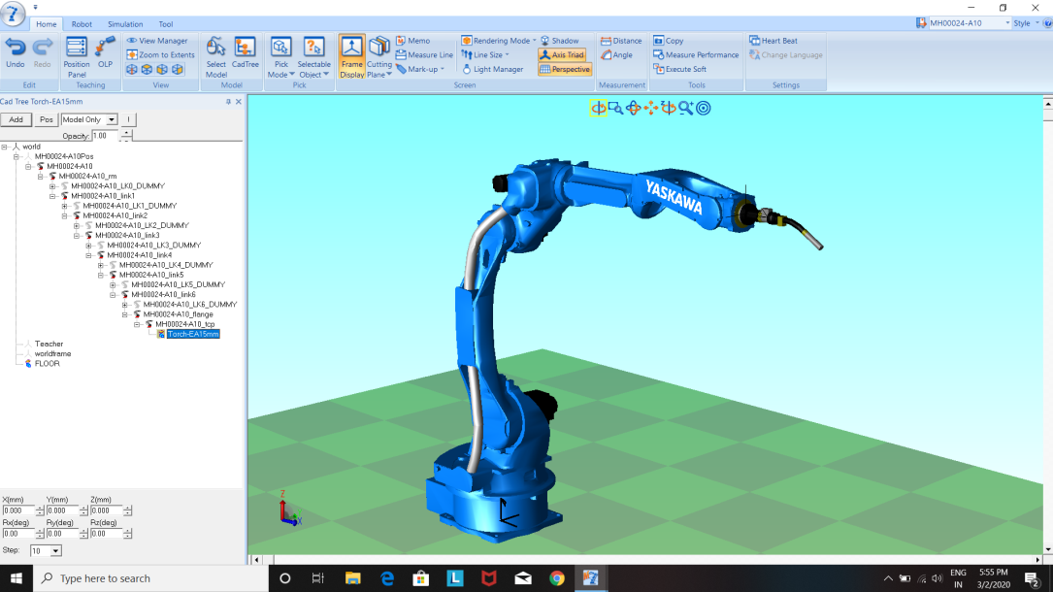

Tool is added and positioned at respective place

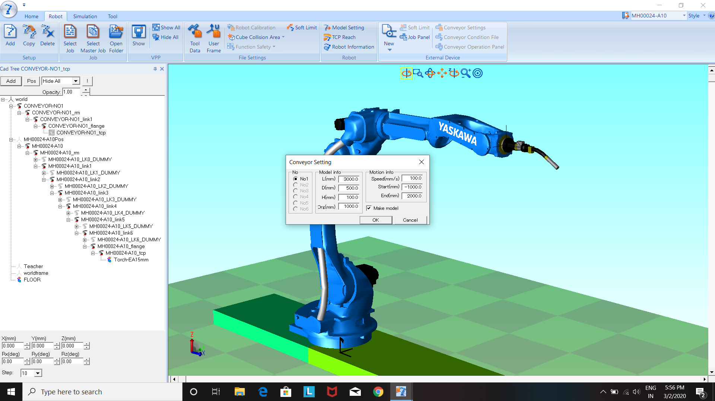

1. **Click on the new option in the robot menu to add a conveyor, press and gantry and then configure the conveyor with length, height, speed, start and end positions of conveyor and we can add up to a total of 6 conveyors.**

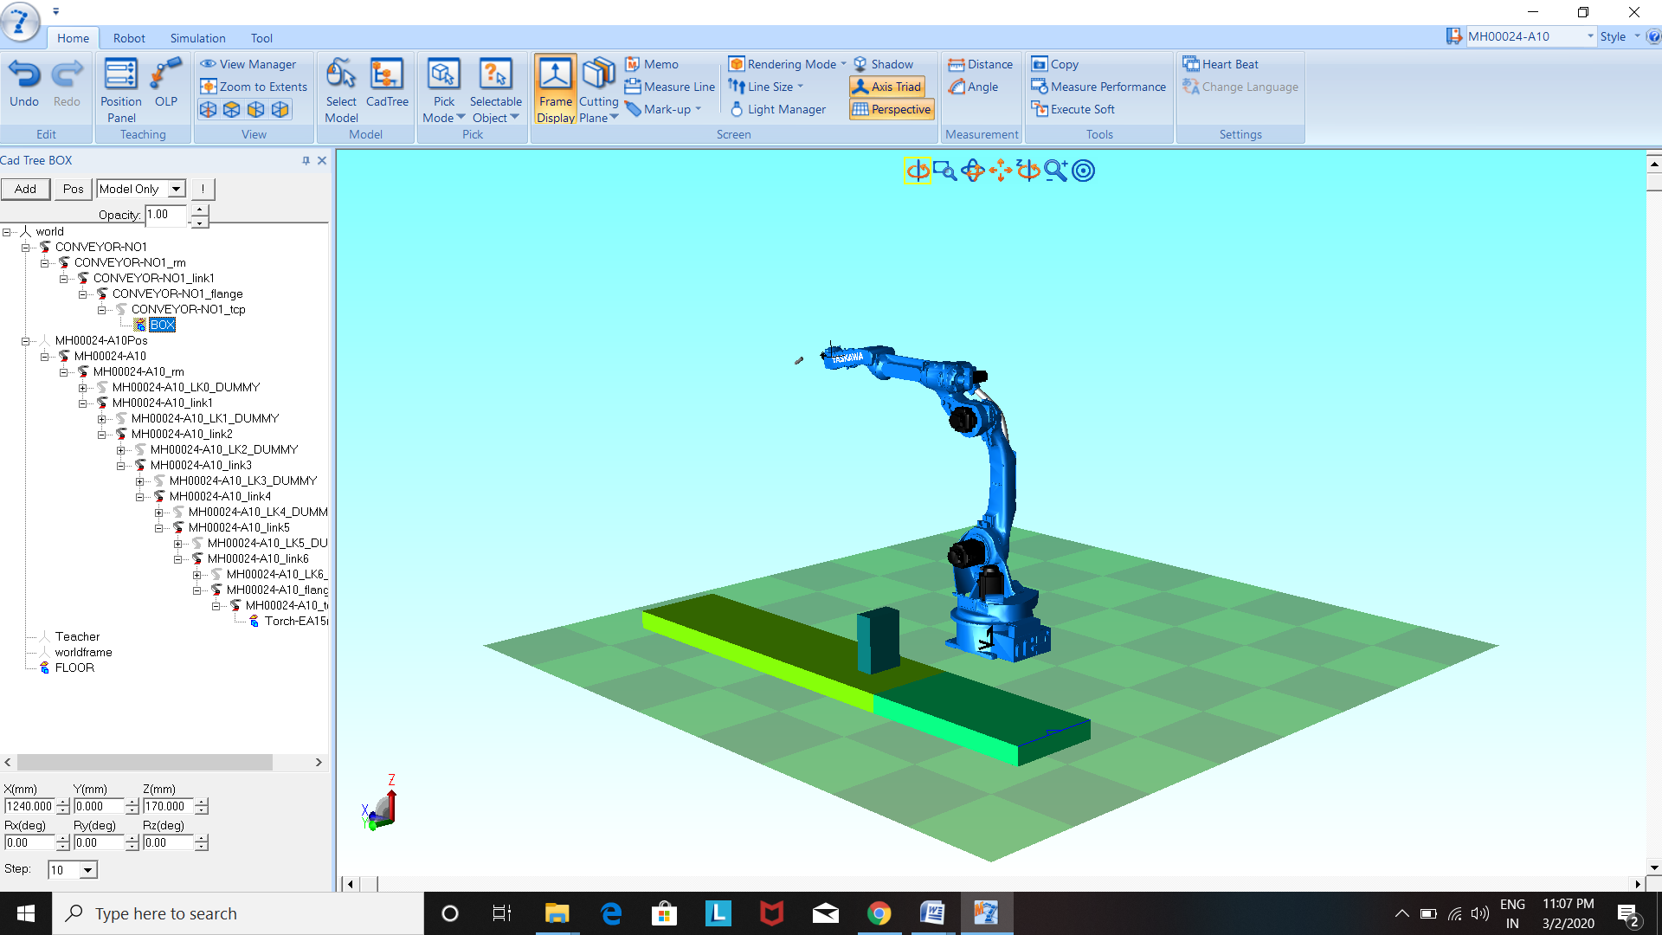

1. **Click on the conveyor top and then add the work or box to work with it and then position it with the dialogue box which is highlighted in button right corner**.

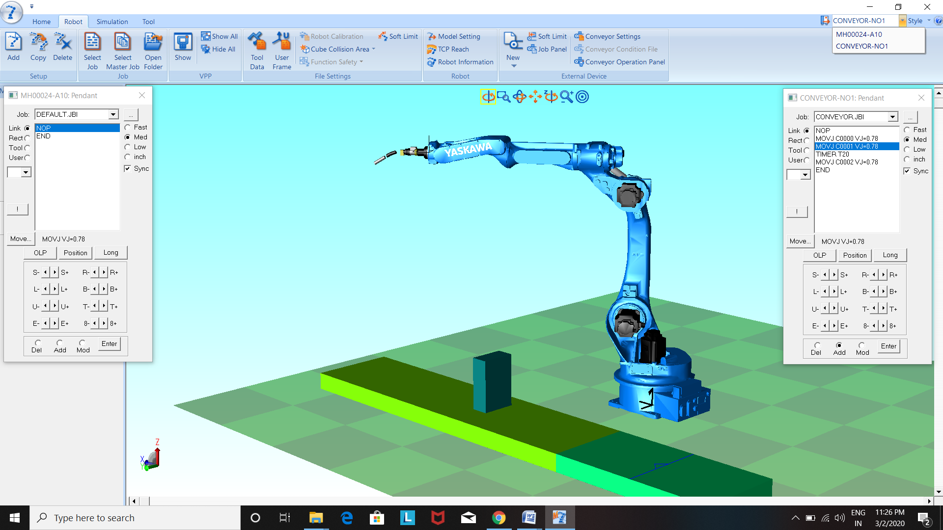

1. **By clicking on the show option as shown above we can get a digital teach pendent which is helpful to teach a robot or the conveyor system. We can get the teach pendent by a popup dialogue box present on the left top of the display.**

**The dialogue boxes on both sides indicate the teach pendant's of MH00024-A10 Robot and conveyor.**

**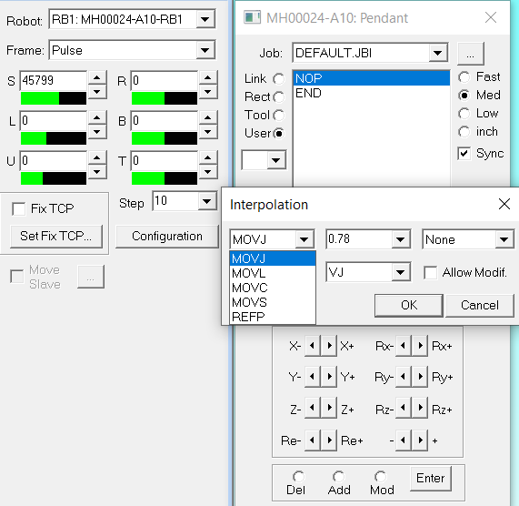**

1. **The robot is teached along the points of the work in four interpolation methods (i.e., circular MOVC, joint MOVJ, linear MOVL, spline M0VS). which can be selected by the MOVE option on teach pendent.**

**We can change the speed of motion of arm with four variations (i.e., FAST, MEDUM, SLOW, INCHES,) which appears on the pendent.**

**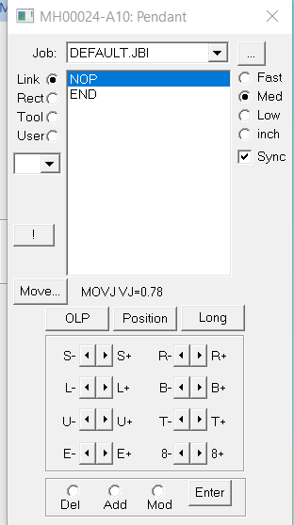 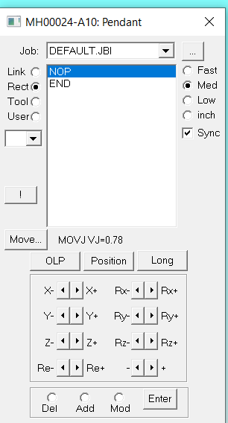 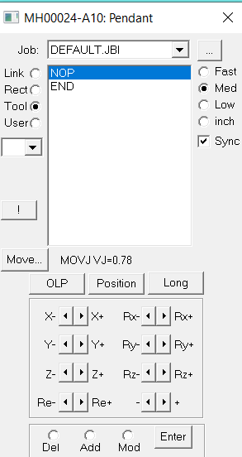**

1. **The above shown diagrams indicate about the movement of joints either movement of joint individually, movement along axis, movement of tools. While teaching whenever the robot reaches to the required point click add to save point, and to delete a point click delete.**

**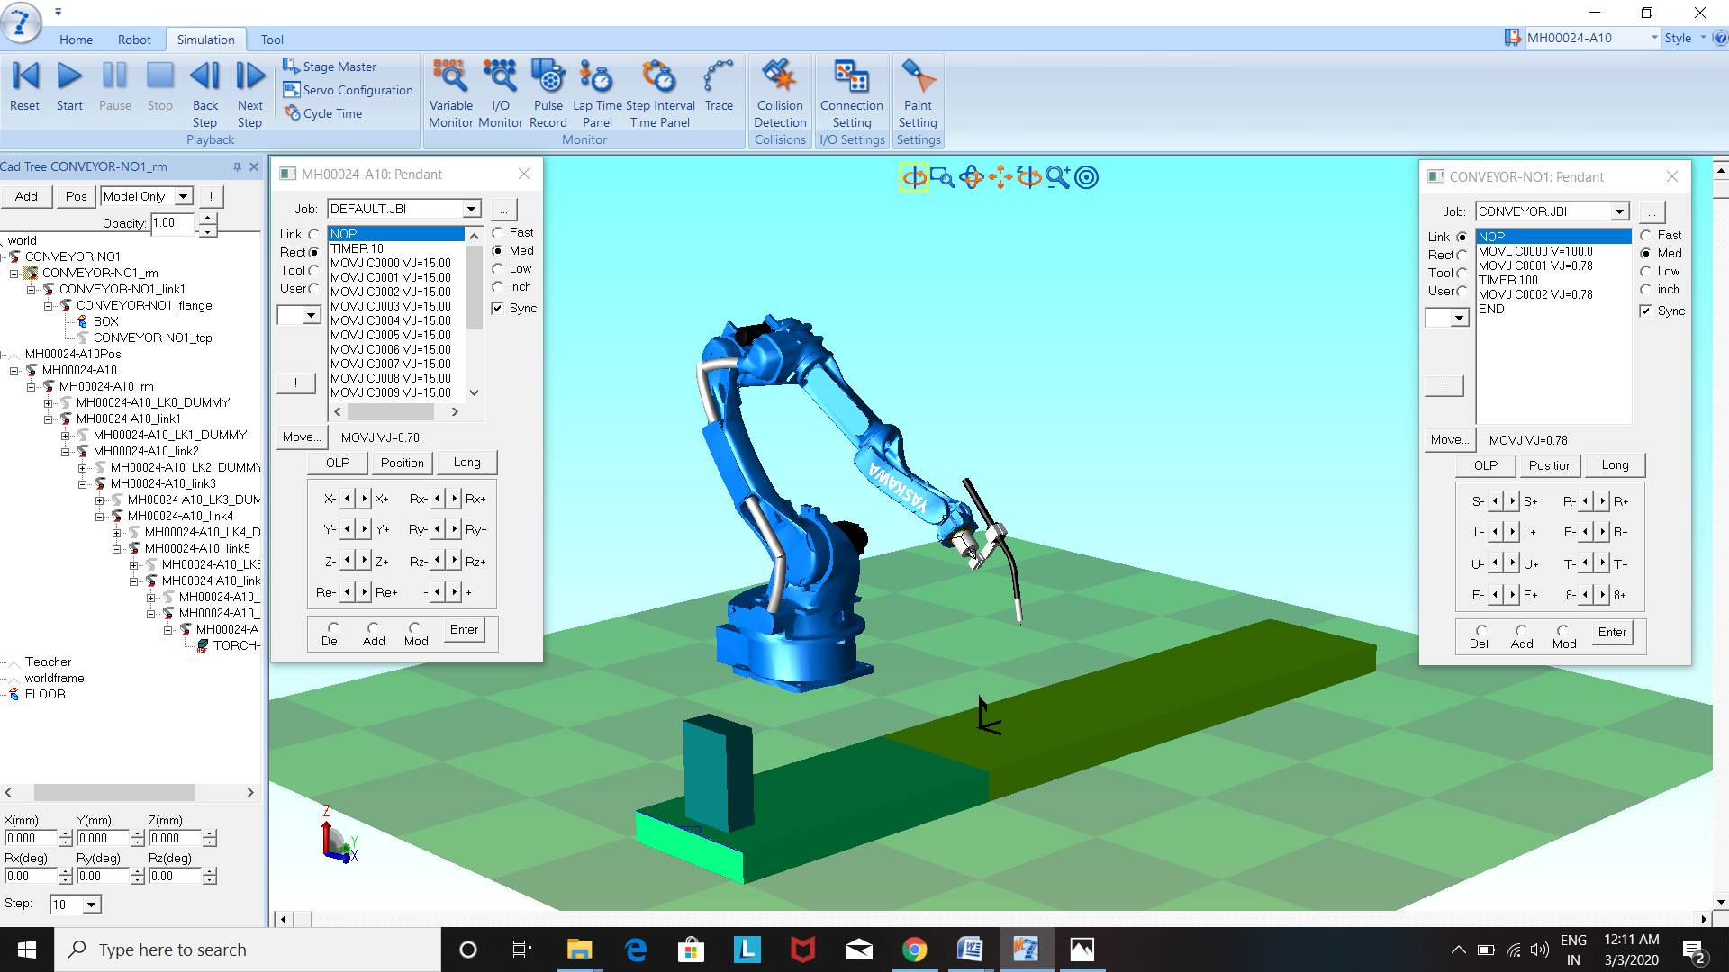**

1. **After teaching the robot with pendent click on the simulation menu and then set the points on both the pendant's to NOP where the program usually begins and then click on the Play option.**

**If you want to edit click on stop and edit in pendant.**

**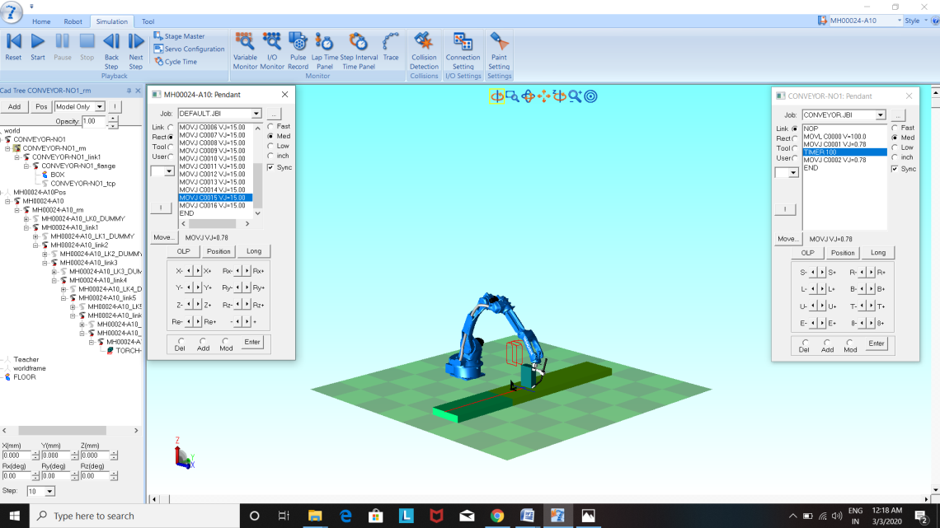**

1. **While the simulation is being carried out the movements of TCP are traced by a red line.**

**ACTIONS ON PENDENT**

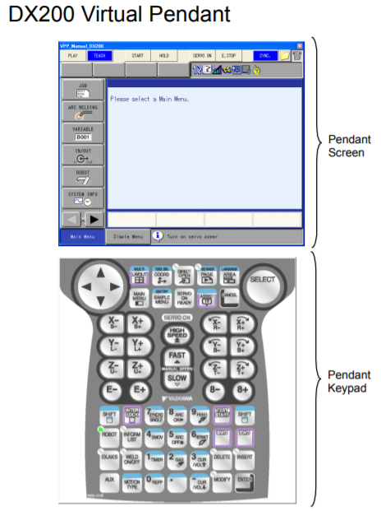

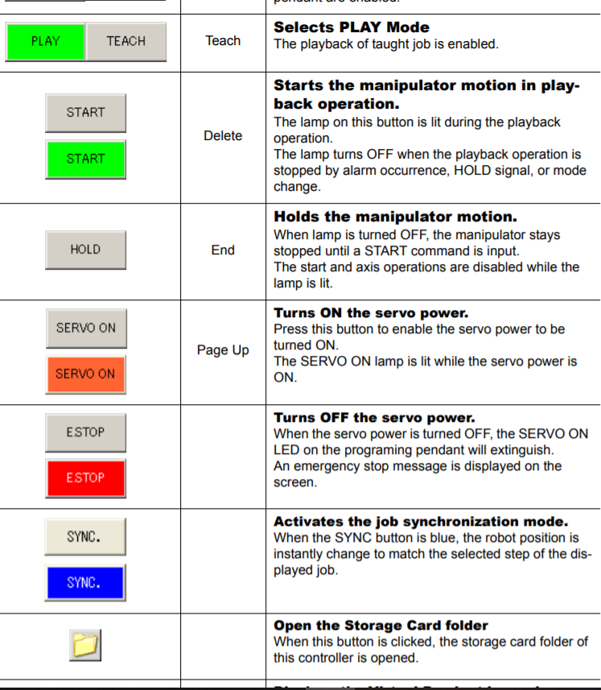

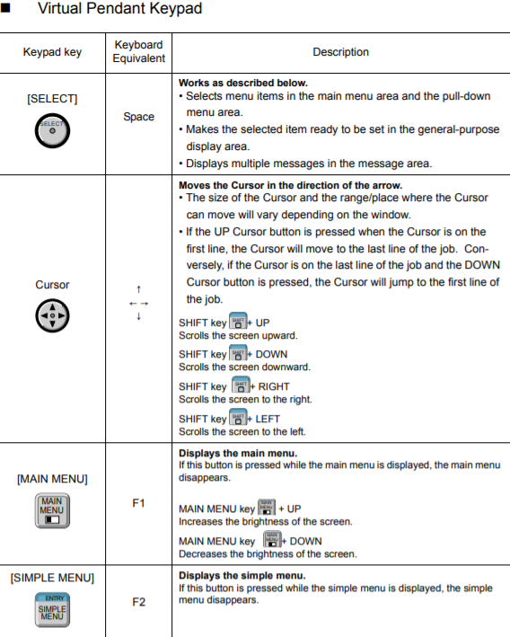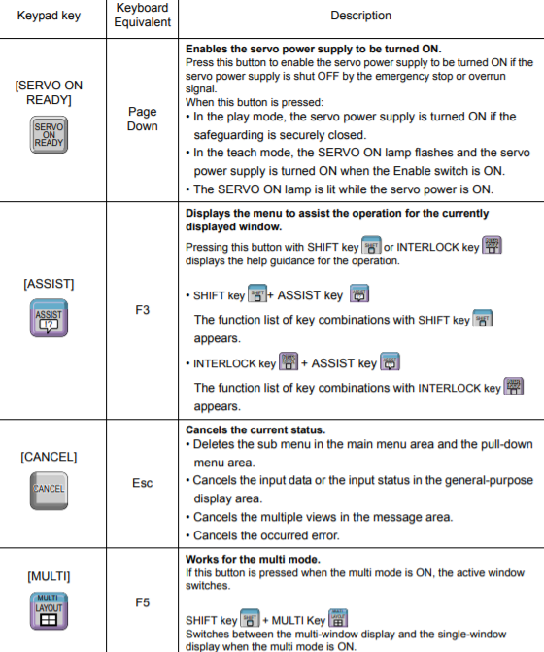

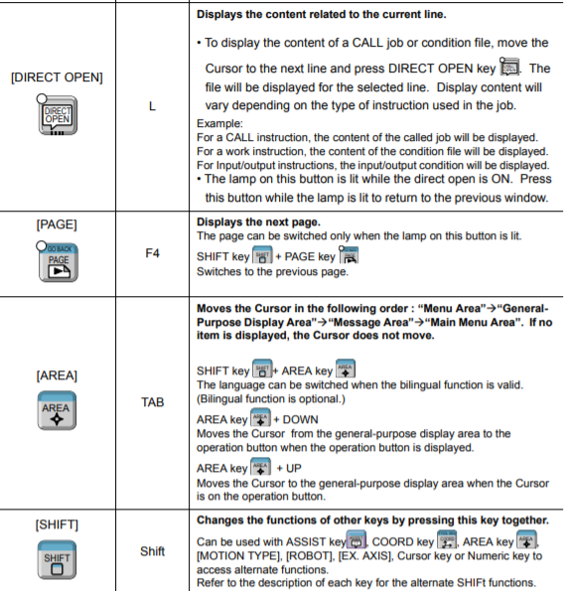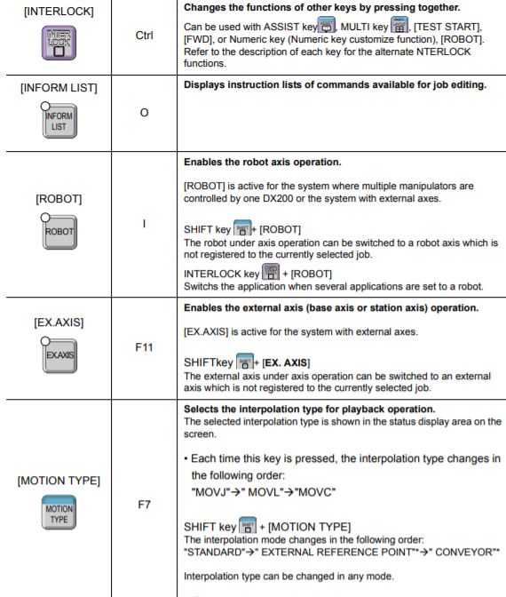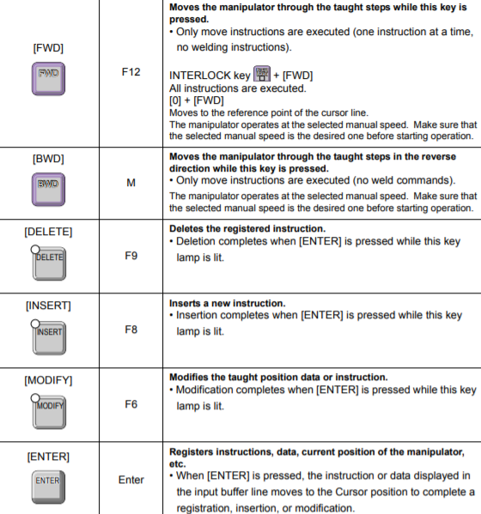

**INTRODUCTION TO PROGRAMMING LOGIC CONTROLLER**

**PLC (PROGRAMMABLE LOGICAL CONTROL)**

A Programmable Logic Controller (PLC) is a small, self–contained, rugged computer designed to control processes and events in an industrial environment – that is, to take over the job previously done with relay logic controllers. Wires from switches, sensors and other input devices are attached directly to PLC. Each PLC contains a microprocessor that has been programmed to drive the output O/P). Terminals in specified manner, based on the signals from the input terminals. The PLC program is usually developed on the separate programmer (PG) computer such as a Personal Computer (PC), using special software provided by the PLC manufacturer. Once the program has been written, it is transferred or downloaded into the PLC. The basic function of a PLC is to provide output commands to a machine or process based on some combination of a set of input condition of a set of input conditions to that machine or process. The PLC is similar to the familiar relay logic panel but with extended capabilities. The internal wiring of a PLC is fixed and the logical function that it must perform are programmed into a “memory”, hence the name “Programmable Controller”. The processor with built in routines scan the input signals and in accordance with the “stored programmed in memory” initiates the required output signals. The PLC may perform timing, counting and other functions dependent on the design of the PLC.

**EVOLUTION OF PLC**

Programmable logic controllers are widely used in automation the process in any type of industry. Relay logic was used well before the invention of PLC. A Programmable logic controller is a solid-state logic control device with a user programmable memory, which is programmed with a user-oriented language. So that it can reads input conditions to machine or process.

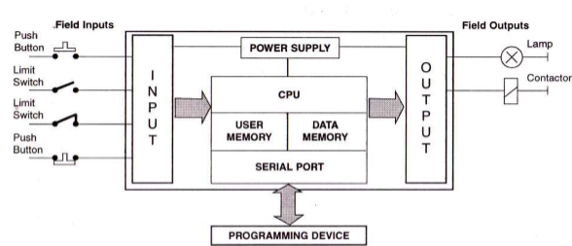

**Advantages of PLC**

1. Programming and modification in the logic is very easy.
2. Easy configuration.
3. Reliability.
4. Maintainability.
5. Fast response time.
6. Expandability.
7. I/O modules to the external world

**Disadvantages of PLC**

1. Function is fixed and complicated.
2. Low response time for a large programming-based process.
3. Up gradation not possible for packaged PLC.

**PLC HARDWARE**

The PLC is basically a programmed interface between the field input devices like limit switches, sensors, transducers, push buttons etc. And the final control elements like actuators, solenoid valves, dampers, drives, LED’s, etc. Programmable controller consists of the following modules:

1. Input modules.

2. CPU with processor and program memory.

3. Output modules.

4. Bus system.

5. Power supply.

1. **Input Module**

The input module acts as an interface between the field control inputs and the CPU. The Voltage or current signals generated by the sensors, transducers, limit switches, push buttons etc. are applied to the terminals of the input module. The input module helps in the following way:

* It converts the field signal into a standard control signal, for processing by the PLC.
* The standard control signal delivered by input module could be 5V or 9V whereas the field signal received by it could be say 24V DC or 230V AC.
* If required, it isolates the field signal from the CPU.

Depending upon the nature of input signal coming from the field, the input module could be,

1. Analog Input Module. 2. Digital Input Module.

The typical analog current input modules are 4 to 20 mA, 0 to 20 mA and analog voltage input module are 0 to 500mV and 0 to 10V. The typical digital input modules are 24V DC, 120V AC and 230V AC. Pressure Transmitter, Temperature Transmitter, Flow Transmitter, Level Transmitter are analog type Proximity Switches, Pressure Switches, Limit Switches, Reed Switches, Encoders are the digital type.

1. **Output Module**

The output module acts as a link between the CPU and the output devices located in the field. The field devices could be relay, contractors, lamps, motorized potentiometers, actuators, solenoid valves, dampers etc. These devices actually control the process. The output module converts the output signal delivered by CPU into an appropriate voltage level suitable for the output field device. The voltage signal provided by CPU could be 5V or 9V, but the output module converts this voltage level into say 24V DC, or 120V AC or 230V AC etc. Thus, the output module on receiving signal from the processor, switches voltage to the respective output terminals. This makes the actuators (i.e. contractors, relays etc) or indicating lights etc. connected to the terminal, to turn ON or OFF. Like input module, an output module could be analog or digital. The selection is based on the voltage rating of the field output devices. If the output device is analog then analog output module is required and if its digital like contractor coil or a lamp then digital output modules have 24V DC, 120V AC, and 230V AC or relay output. Control Valve, Servo Valve Variable, Frequency Drives, I/P Converters are analog type. Solenoid Valves, Relays ,Drives ,Alarms, Motors are the digital type.

1. **Central Processing Unit**

The central Processing Unit or CPU consists of the following blocks.

* Arithmetic Logic Unit (ALU)
* Program memory
* Process image memory (i.e. internal memory of CPU)
* Internal timers and counters
* Flags

1. **Power Supply**

The power supply module generates the voltages required for the electronic modules of the PLC from the main supply. Typically single phase, 230V AC supply is converted into 24V DC supply by power supply module. It should be noted that CPU needs 24V DC input, and the CPU generates the other voltage required by the PLC hardware such as 5V DC etc.

1. **Bus System**

Bus system is a path for the transmission of signals. In the programmable controllers, it is responsible for the signal exchange between processor and input / output modules. The bus comprises of several signal lines i.e. wires / tracks. There are three buses in PLC named,

1. Address bus, which enables the selection of memory location or a module.
2. Data bus, which carries the data from modules to processor and vice versa.
3. Control bus, which transfers control and timing signals for the synchronization of the CPU’s activities within the programmable controller.

In addition to the above listed modules, the other frequently used modules in a PLC system are;

Interface Module

Communication Processor Module

Function Module or Intelligent Periphery Module.

**OPERATION OF PLC**

**Bringing Input Signal Status to the Internal Memory of CPU**

As discussed earlier, the field signals are connected to input module. At the output of input module the field status is converted into a voltage level that is required by the CPU. At the beginning of each cycle the CPU brings in all the field-input signals from input module and stores into its internal memory as process image of input signal. This internal memory of CPU is called as PII (Process Image Input). The programmable controller operates cyclically i.e. when the program has been scanned; it starts again at the beginning of the program.

**Processing of Signals Using Program & Updating PIQ**

Once the field-input status is brought into the internal memory of CPU i.e. in PII, the execution of user program, statement-by-statement begins. Based on the user program the CPU performs logical and arithmetic operation on the date from PII. It also processes times and counts as well as flag states based on the instructions. The results of the user program scan i.e. decision are then stored in the internal memory of CPU. This internal memory is called Process Image Output or PIQ.

**Sending Process Output Image to Output Module**

At the end of the program run i.e. at the end of scanning cycle, the CPU transfers the signal states in the process image output to the output module and further to field control.

**DELTA(PLC):** 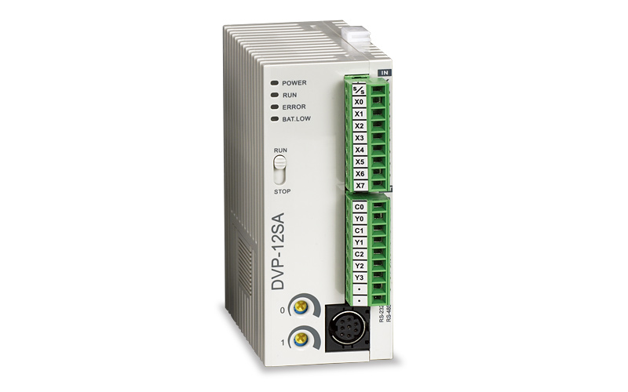

Programmable logic controller (PLC) is a control system using electronic operations. It's easy storing procedures, handy extending principles, functions of sequential/position control, timed counting and input/output control are widely applied to the field of industrial automation control. Delta's DVP series programmable logic controllers offer high-speed, stable and highly reliable applications in all kinds of industrial automation machines. In addition to fast logic operation, bountiful instructions and multiple function cards, the cost-effective DVP-PLC also supports various communication protocols, connecting Delta's AC motor drive, servo,human machine interface and temperature controller through the industrial network in to a complete “Delta Solution” for all users.

Delta's DVP series programmable logic controllers offer high-speed, stable and highly reliable applications in all kinds of industrial automation machines. In addition to fast logic operation, bountiful instructions and multiple function cards, the cost-effective DVP-PLC also supports various communication protocols, connecting Delta's AC motor drive, servo, and human machine interface and temperature controller through the industrial network in to a complete “Delta Solution” for all users.

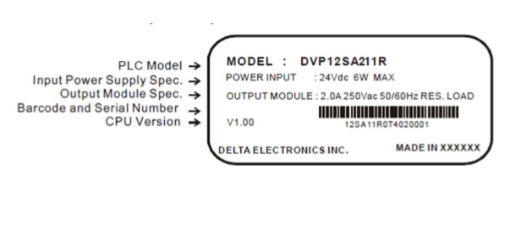**MODEL SPECIFICATION**

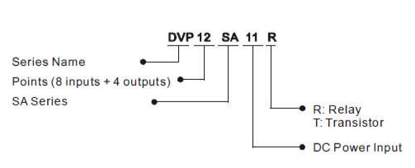

**Miniature Circuit Breakers (MCB)**

An MCB or miniature circuit breaker is an electromagnetic device that embodies complete enclosure in a molded insulating material. MCBs are used primarily as an alternative to the fuse switch in most of the circuits.

The main function of an MCB is to switch the circuit, i.e., to open the circuit (which has been connected to it) automatically when the current passing through it (MCB) exceeds the value for which it is set.

It can be manually switched ON and OFF as similar to normal switch if necessary. It is commonly used in the low voltage networks.

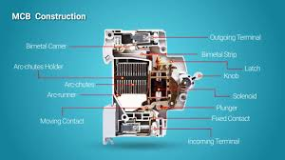

**SMPS**

The power supply circuit in any electrical and electronic circuit plays a vital role to give the power to the entire circuit. The different circuits require various kinds of power at different ranges and characteristics. So, the power is changed into the required form by adopting different power converters. Fundamentally, different types of circuits work with various kinds of power supplies such as SMPS. The term SMPS stands for switch mode power supply, AC to DC power supply, AC power supply, high voltage power supply programmable power supply, and UPS (uninterruptible power supply).

SMPS is a complex circuit such as other power supplies; it provides the supply from a source to the loads

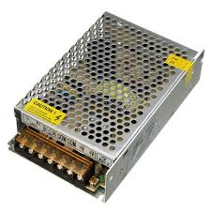

**Relay Card**

Relays are switches that open and close circuits electromechanically or electronically. Relays control one electrical circuit by opening and closing contacts in another circuit. As relay diagrams show, when a relay contact is normally open (NO), there is an open contact when the relay is not energized. When a relay contact is Normally Closed (NC), there is a closed contact when the relay is not energized. In either case, applying electrical current to the contacts will change their state.

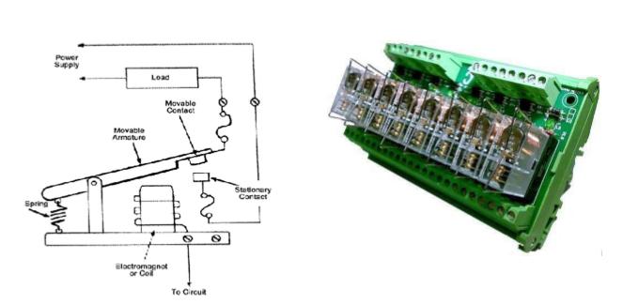**Terminal Block**

A terminal block (also called as connection terminal or terminal connector) is a modular block with an insulated frame that secures two or more wires together. It consists of a clamping component and a conducting strip

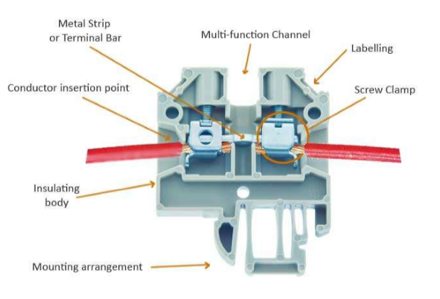

**Fused connection terminals**

These are similar to the pass-through blocks with an exception of the metal connection strip is replaced with a fuse. Therefore, the wires will be connected through a fuse providing an added protection.

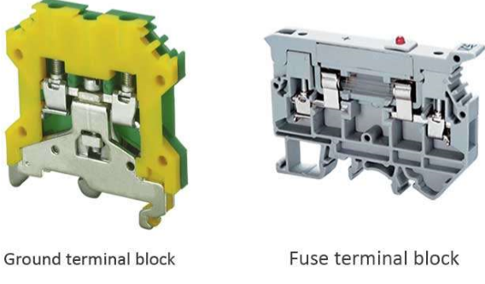

**HOW TO START WITH DELTA PLC:**

* Click the delta PLC named as Delta WPL Soft icon in the desktop.
* Then a new page will be open as shown below.
* Then select a PLC model SA2 and then click ok

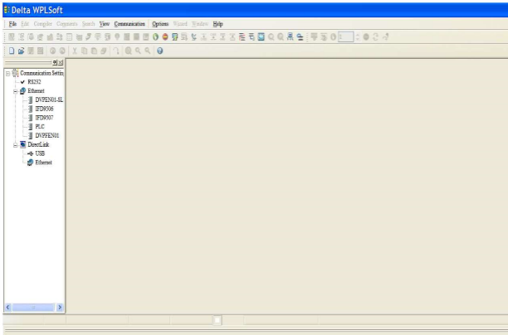

* Then select a PLC model SA2 and then click ok

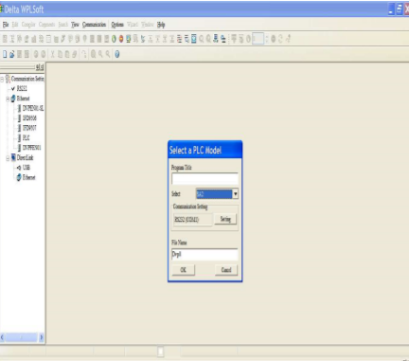

* Then a blank page will be opened to enter the program.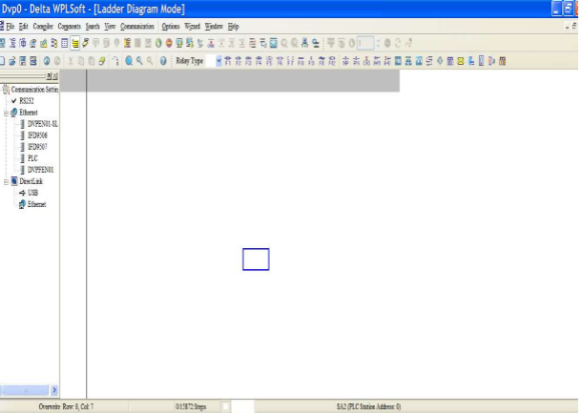
* Then entered the program that to be run the project.

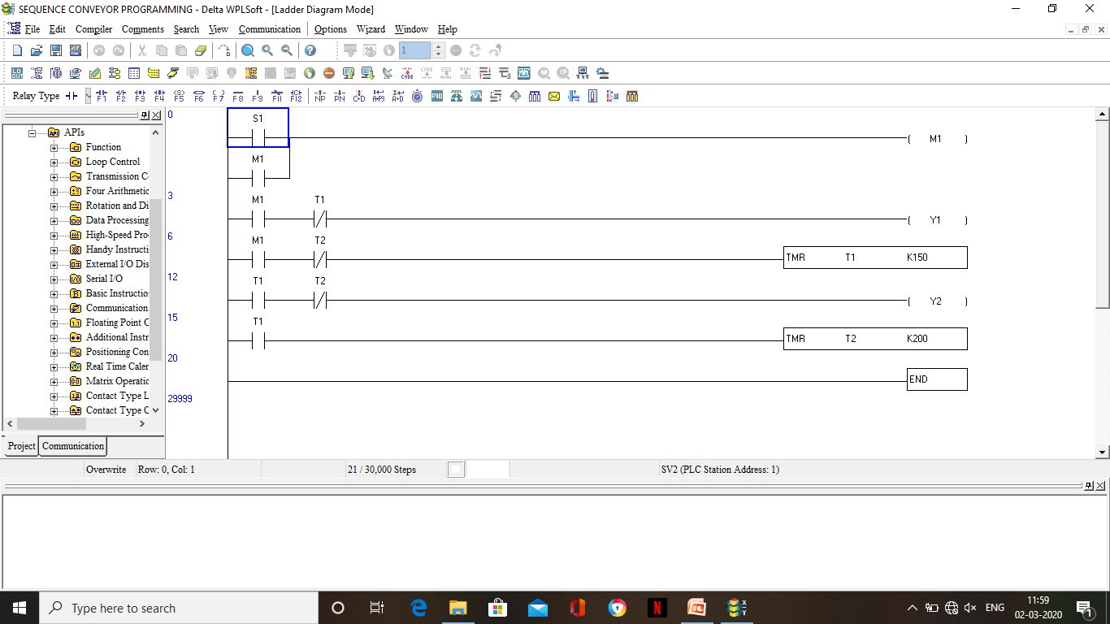

* The program is written and then to execute it, we should click on the simulator button.
* Click on the online mode and then run.

**WORKING OF THE CONVEYOR:**

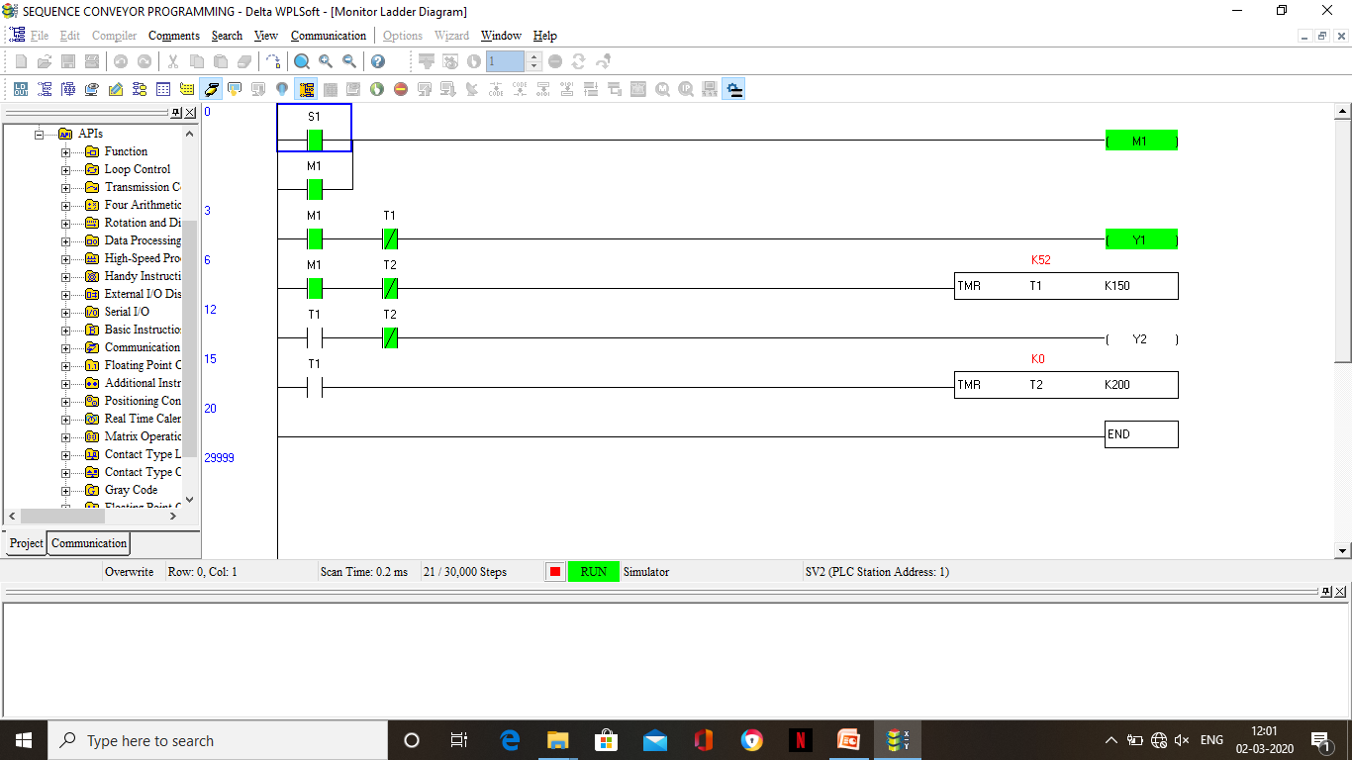

1. To set the S1 ON click on the sensor and then a pop-up window appears where you can set the sensor ON thereby; we can set the turn the motor on which helps to move the work piece to desired position.

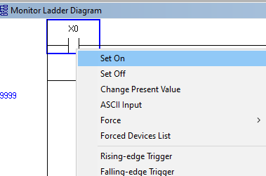 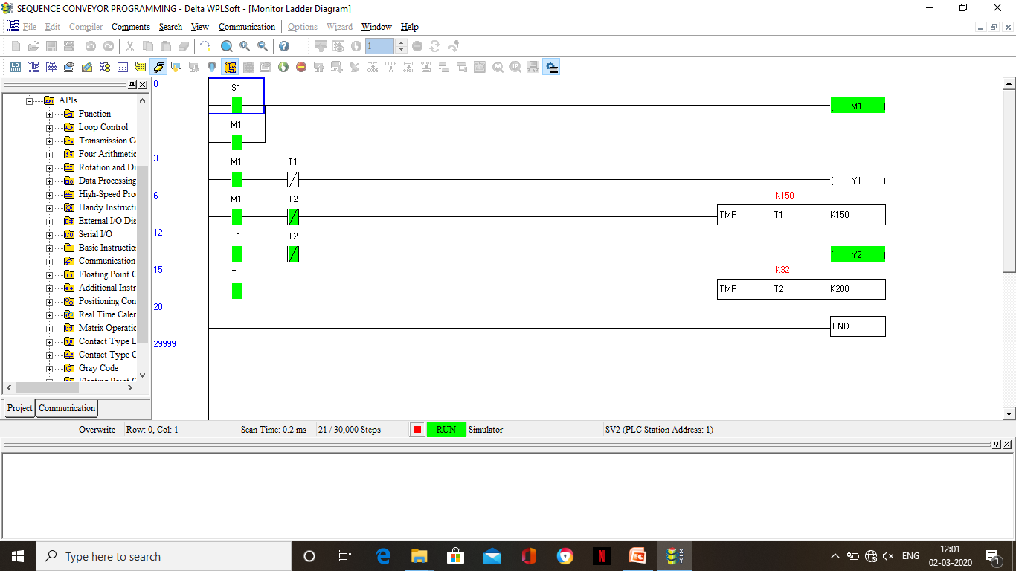

1. After the TIMER T1 is completed the MOTOR Y1 automatically stops and the TIMER T2 turns ON.
2. While the TIMER T2 is ON, the ROBOT Y2 stars to work.

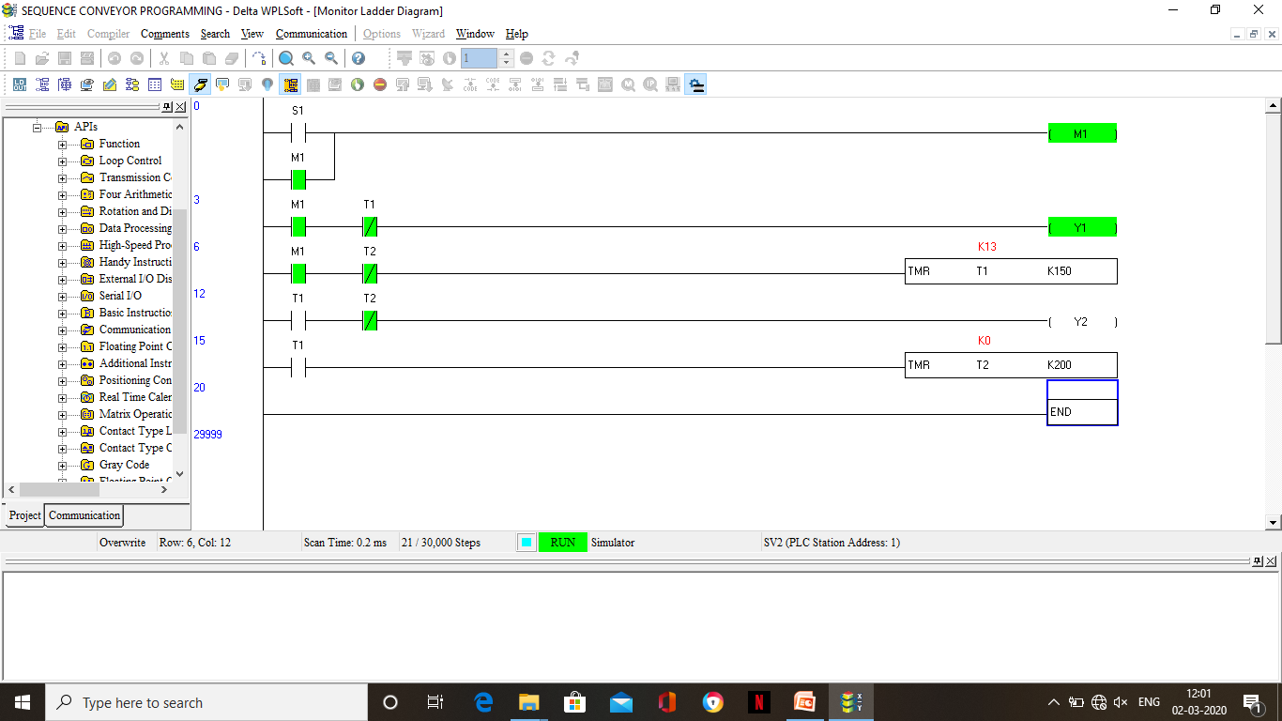

1. After the TIMER T2 completes, the ROBOT Y2 turns off and then both the timers are set to ZERO.
2. And this process continues in a loop till the sensor S1 is OFF.

**INTRODUCTION TO**

**SUPERVISORY CONTROL AND DATA ACQUISITION**

**(SCADA)**

The Supervisory Control and Data Acquisition (SCADA) is one of the solutions available for data acquisition, monitor and control systems covering large geographical areas. It refers to data acquisition and telemetry. SCADA systems are mainly used for the implementation of monitoring and control system of an equipment or a plant in several industries like power plants, oil and gas refining, water and waste control, telecommunications, etc. SCADA

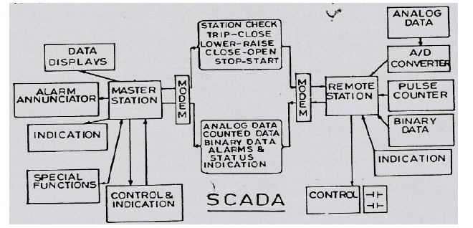

FIG.1 SCADA WITH TWO MODEM CONNECTED

SCADA is an acronym for Supervisory Control and Data Acquisition. SCADA systems are used to monitor and control a plant or equipment in industries such as telecommunications, water and waste control, energy, oil and gas refining and transportation. These systems encompass the transfer of data between a SCADA central host computer and a number of Remote Terminal Units (RTUs) and/or Programmable Logic Controllers (PLCs), and the central host and the operator terminals. A SCADA system gathers information (such as where a leak on a pipeline

has occurred), transfers the information back to a central site, then alerts the home station that a leak has occurred, carrying out necessary analysis and control, such as determining if the leak is critical, and displaying the information in a logical and organized fashion. These systems can be relatively simple, such as one that monitors environmental conditions of a small office building, or very complex, such as a system that monitors all the activity in a nuclear power plant or the activity of a municipal water system. Traditionally, SCADA systems have made use of the

Public Switched Network (PSN) for monitoring purposes. Today many systems are monitored using the infrastructure of the corporate Local Area Network (LAN)/Wide Area Network (WAN). Wireless technologies are now being widely deployed for purposes of monitoring.

**SCADA**

Supervisory control and data acquisition (SCADA) is a system for remote monitoring and

Control that operates with coded signals over communication channels.(using typically one communication channel per remote station).

SCADA is an industrial automation control system at the core of many modern

Industries, including energy.

* SCADA is purely a 100% software which is nothing but application development

Of the real-time industry with animation representation.

* Addresses in SCADA are represented as “tag names”.
* Evaluating a process seconds by seconds can be done.

***SCADA systems consist of:***

* One or more field data interface devices, usually RTUs, or PLCs, which interface to field sensing devices and local control switchboxes and valve actuators.
* A communications system used to transfer data between field data interface devices and control units and the computers in the SCADA central host. This system can be radio, telephone, cable, satellite, etc., or any combination of these.
* A central host computer server or servers (sometimes called a SCADA Center, master station, or Master Terminal Unit (MTU).
* A collection of standard and/or custom software [sometimes called Human Machine Interface (HMI) software or Man Machine Interface (MMI) software] systems used to provide the SCADA central host and operator terminal application, support the communications system, and monitor and control remotely located field data interface devices.

**WONDERWARE INTOUCH**

MAKE - SCHNEIDER (INVENSYS SYSTEM, Inc.).

NAME - WONDERWARE INTOUCH.

VERSION - INTOUCH 10

**Wonderware Intouch Architecture**

In Wonderware Intouch the program has to be done in the Window Maker and the working scripts also written in the windows script of the Window Maker. This Window Maker is called as development screen. And the simulation was seen in the runtime screen.

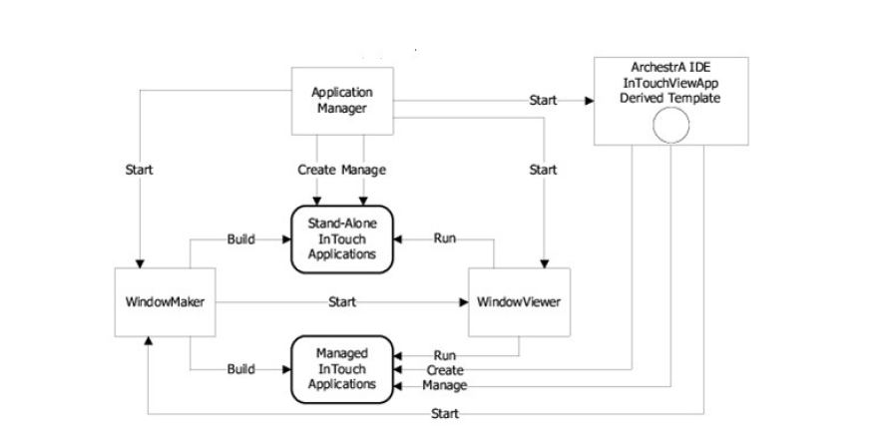

Fig.2 Intouch Architecture

**Three windows of Wonderware Intouch:**

Application manager – Place where the file screen saves

Window maker – Place where design saves

Windows viewer – Place where runtime visualization is done

***To create a project in Wonderware:***

* **Open the Wonderware Intouch screen.**

**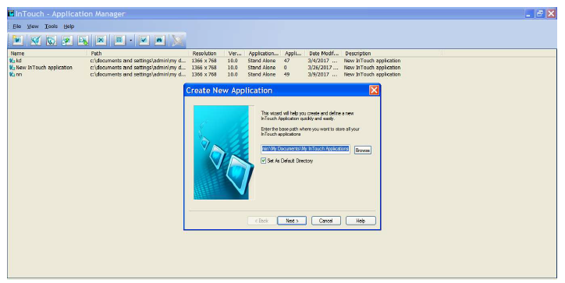**

* **Give the new name for the screen click next button and a new page will be opened.**

**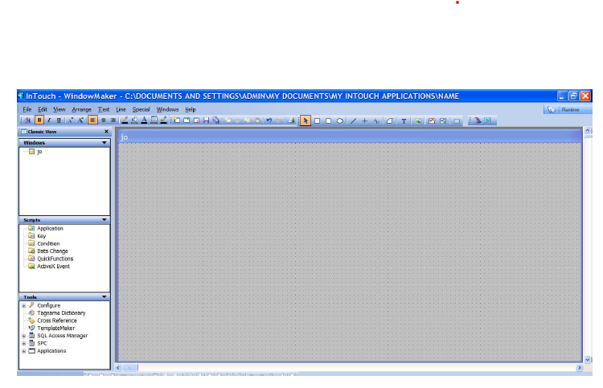**

* **Make a design in the window viewer in development page and go to runtime to execute it.**

**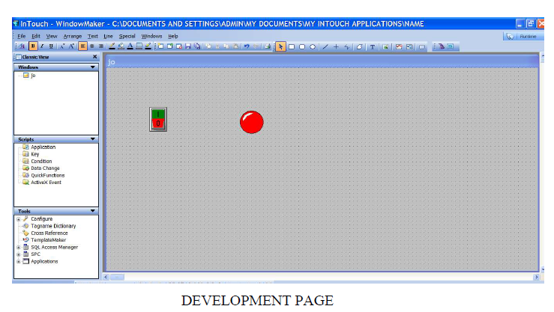**

**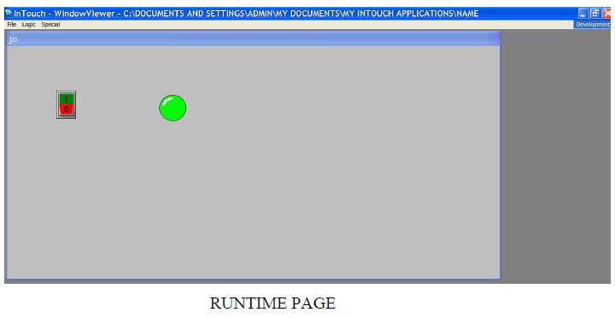**

**FUTURE SCOPE**

International Federation of Robotics, robot density in India stands at a measly 3 robots per 10k employees. This is in stark comparison to other Asian powers like South Korea which has the highest robot density in the world at 631 robots, followed by Singapore with 488 robots per 10k employees and Japan at 303 robots.

Yet, not all is grim and dark. You’d be surprised to know significant steps have already been taken in India when it comes to robotics and AI. Industries such as manufacturing, healthcare, and construction are leading the demand for robotics talent. In fact, robotics would be a boon for the Indian healthcare industry. Due to India’s ballooning population (1.36 billion) and a doctor-patient ratio of 1:1674 (as against WHO norm of 1:1000), India would benefit greatly from the use of technologies like surgical robots, robot-assisted diagnostics, telesurgery, AI-based medical bots, etc.

And when the topic is robots, how can edutech robotics be far behind? Efforts are being made to include robotics as a part of curriculum across schools in the country. Avishkaar is one such entity which is working towards this making these visions a reality. Through its range of DIY robotics kits, and emphasis on ‘Making’ culture, Avishkaar is doing its part.

But before we move forward, let’s take a look at the current scenario of the robotics industry in India.

**Present Scenario of Robotics in India**

Robotics is pervading in a number of industries irrespective of the fact that they’re labor intensive in nature or not. There’s increased use of robots in warehouses where they perform jobs from heavy lifting to inventory collection and other assorted jobs. The Indian market for warehouse automation is expected to grow at a CAGR of 10-12 percent between 2015-2020 and reach US $3.49bn by 2020.

The future is bright for both robots and humans. The industry is on the cusp of exploding in the country has access to Internet connectivity and open source applications become more widespread. Even though people have a fear of automation taking away jobs from us humans, in fact, more job opportunities are being created for skilled personnel.

**CONCLUSION**

THIS PROJECT INTRODUCTED THE CONCEPT OF SYSTEM IN WHICH WE FIND MOST ROBOTS WORKING FOR PEOPLE IN INDUSTRIES, FACTORIES, WAREHOUSES, AND LABORATORIES. ROBOTS ARE USEFUL IN MANY WAYS. FOR INSTANCE, IT BOOSTS ECONOMY BECAUSE BUSINESSES NEED TO BE EFFICIENT TO KEEP UP WITH THE INDUSTRY COMPETITION. THEREFORE, HAVING ROBOTS HELPS BUSINESS OWNERS TO BE COMPETITIVE, BECAUSE ROBOTS CAN DO JOBS BETTER AND FASTER THAN HUMANS CAN, E.G. ROBOT CAN BUILT, ASSEMBLE A CAR. YET ROBOTS CANNOT PERFORM EVERY JOB; TODAY ROBOTS ROLES INCLUDE ASSISTING RESEARCH AND INDUSTRY. FINALLY, AS THE TECHNOLOGY IMPROVES, THERE WILL BE NEW WAYS TO USE ROBOTS WHICH WILL BRING NEW HOPES AND NEW POTENTIALS.